

**Web Application Pen-Testing**

**SCHOOL OF INFOCOMM TECHNOLOGY**

Diploma in Cyber Security & Forensics

**Client Report**

**Team FTK**

|  |  |
| --- | --- |
| Name | Student Number |
| Kok Jia Cheng, Glenn | S10208391 |
| Colin Foo Chi Yang | S10194197 |
| Tan Yi Qian | S10204851 |

The following Client report was compiled and written by the team on 19th January 2022.

|  |
| --- |
| Shape  Description automatically generated with medium confidenceKok Jia Cheng, Glenn |

Name & Signature of Pen-Test Team Member 1 (Pen-Test Team Lead)

|  |
| --- |
| 19/1/2022 |

Date 19 January

|  |
| --- |
| Colin Foo Chi Yang |

Name & Signature of Pen-Test Team Member 2

|  |
| --- |
| 19/1/2022 |

Date

|  |
| --- |
| Tan Yi Qian |

Name & Signature of Pen-Test Team Member 3

|  |
| --- |
| 19/1/2022 |

Date

**Executive Summary**

Over the course of this penetration testing exercise, Team FTK identified 1 critical vulnerability that could lead to full compromise of the system. Additionally, other high severity issues that can potentially impact the web application were also discovered and addressed in this report. The executive summary will introduce the most severe vulnerabilities highlighted by the team. More information regarding the vulnerabilities discovered is addressed in the Vulnerability Summary Findings section.

**SQL Injection**

The contents of the database were compromised due to a SQL injection vulnerability. This attack attempts to extract and disclose sensitive data from the database such as user login credentials. Due to lack of input validation on the server-side and protective measures, this vulnerability was successfully exploited from a non-privileged user account and should be mitigated immediately.

**Broken Authentication**

Due to a lack of account authentication restrictions and controls, the web application login pages are vulnerable to brute-force attacks. This can allow an attacker to use a list of possible usernames and passwords to discover valid user accounts or gain administrative access.

**Broken Access Control**

Specific pages in the web application had no verification or lacked access control restrictions and were subjected to unauthorized access. This includes accessing sensitive information that should not be revealed, performing unauthorized actions, and accessing administrative pages.

**Cross-Site Scripting (XSS)**

A certain page on the web application contains an input field that allows users to submit malicious scripts into the database. Due to lack of input and output sanitization, these malicious scripts have the potential to impact the availability of that page as well as redirect and deceive legitimate users to enter credentials on a replicated login page set up by an attacker.

Overall, a reasonable level of security has been attained by the web application. However, due to certain misconfigurations, lack of input validation, and incorrect implementation, the web application was compromised. The results of the exploitation of vulnerabilities found in the web application include disruption of service, disclosure of sensitive information, and obtaining login credentials of valid users. These threats can potentially impact HRCMS-Admin web application’s confidentiality, integrity, and availability.

Table of Contents

1 Introduction 1

2 Client Information 3

3 Pen-Test Schedule 4

4 Information Gathering Summary Findings 5

4.1 Passive Reconnaissance 5

4.2 Active Reconnaissance 6

5 Vulnerabilities Summary Findings 8

5.1 SQL Injection Vulnerability 10

5.2 Authentication Brute-force Vulnerability 11

5.3 Broken Access Control Vulnerability 12

5.4 Cross Site Scripting (XSS) Vulnerability 13

5.5 HSTS Missing from HTTPS Server 14

5.6 FTP, POP, IMAP, and SMTP Credentials Transmitted Unencrypted 15

5.7 X-Frame-Options Header Not Set 16

5.8 Browsable Web Directories 17

5.9 Application Error Disclosure 18

5.10 Absence of Anti-CSRF Tokens 19

5.11 Vulnerable JS Library 20

5.12 Insufficient Logging & Monitoring Vulnerability 21

5.13 Web Application Cookies Not Marked Secure 22

6 Exploitation & Post-Exploitation Summary Findings 23

6.1 Cross-Site Scripting (XSS) 23

6.2 Broken Access Control 26

6.3 SQL Injection 29

6.4 Broken Authentication 32

6.5 Unrestricted File Upload 34

7 Recommendations 36

8 Summary 38

Appendices 39

A. Signed-Off Scope Document 39

B. Signed-Off Rules of Engagement Document 42

C. Signed-Off Agreement/Contract 45

D. Signed-Off Non-Disclosure Document 57

E. Proof-of-Concept Use Cases 61

F. Severity Ranking Table 61

# Introduction

Team FTK, from the School of InfoComm Technology, Ngee Ann Polytechnic was tasked to perform penetration testing on the HRCMS-Admin web application belonging to Tri-Niche. The primary goal of this web application grey box penetration testing project was to identify any potential areas of concern associated with the application in its current state and determine the extent to which the system may be compromised by an attacker possessing a particular skill and motive. The assessment was performed in accordance with the Open Web Application Security Project (OWASP) and the guidelines by Ngee Ann Polytechnic.

The penetration testing project was conducted during the period of 23rd November 2021 to 29th January 2022. All testing activities were performed on the staging environment provided by the client, Tri-Niche. It was stated by the client that the web application is in production but no longer maintained; hence, it was used as the staging site. The tests were carried out assuming the identity of an attacker or a malicious user, but no harm was made to the functionality or working of the application.

The scope of this exercise was limited to a single web application portal.

|  |  |
| --- | --- |
| Application | Authentication Landing Page |
| HRCMS-Admin Web Application | <https://hrcms-admin.tri-niche.com> |

The testing included both unauthenticated as well as authenticated testing. For the purpose of the exercise, 2 unique accounts were provided with different privileges for access to the web application. These accounts were used to test the application’s internal security controls. These accounts are listed in the table below. Since the web application is tested by other teams as well, another non-privileged user was created for exclusive usage by the team.

|  |  |  |  |
| --- | --- | --- | --- |
| Account name | Username | Password | Access Level |
| Erwin | erwin | 123 | Employee (User) |
| admin | admin123 | 123 | Employer (Admin) |
| FTK | testftk | 123 | Employee (User) |

The team is to perform information gathering and profiling of the web application. This is followed by vulnerability scanning through the use of various automated tools as well as manual assessments for verification and in-depth discovery. From the vulnerabilities discovered, only the most severe vulnerabilities deemed by the team would be exploited.

This report covers the detailed processes, findings, and outcomes of the penetration testing exercise conducted by Team FTK. Recommendations on mitigating the vulnerabilities discovered will also be addressed in this report.

# Client Information

Tri-Niche is a social enterprise that focuses on harnessing the power of Information Technology (IT) to assist welfare entities and companies such as building innovative apps to resolve their IT constraints and address social issues. Tri-Niche offers low cost, high efficiency IT services for social welfare organizations and companies that serve social causes.

Tri-Niche Pte Ltd is registered in Singapore and Tri-Niche Indonesia is registered in Indonesia. Mr. Josh Ching is the owner of Tri-Niche Pte Ltd.

Mr. Erwin Tris Sanjaya was the representative of Tri-Niche within this pen-testing development with Team FTK and its affiliated members.

The contact details of Mr. Erwin Tris Sanjaya are as follows,

|  |  |
| --- | --- |
| Type | Details |
| Name | Erwin Tris Sanjaya |
| Contact No. | +62 896-7530-4040 |
| Email | [erwin@tri-niche.com](mailto:erwin@tri-niche.com) |
| Address | DS Offices Tech Hub, Semarang Plaza Lt.1, No 107, Jl. K.H. Agus Salim No.7 Kauman, Semarang 50137 |

# Pen-Test Schedule

The penetration testing exercise was conducted between 10th December 2021 to 29th January 2022. However, establishment of the documents and engagement with the client started on 23rd November 2021. A strict methodology was followed in conducting the exercise which consist of the pre-testing phase, testing phase, and post-testing phase. Throughout this report, the methodology used would be elaborated along with the information and findings discovered.

The table below depicts an overview of the penetration testing project:

Table 1 – Pen-test Schedule

|  |  |  |
| --- | --- | --- |
| Start Date | End Date | Details |
| 23/11/2021 | 29/11/2021 | Scoping and Establish Rules of Engagement |
| 30/11/2021 | 04/12/2021 | Contract Signing |
| 10/12/2021 | 17/12/2021 | Project Planning |
| 18/12/2021 | 21/12/2021 | Information Gathering |
| 21/12/2021 | 23/12/2021 | Profiling the Web Site |
| 21/12/2021 | 23/12/2021 | Vulnerabilities Scanning |
| 27/12/2021 | 20/01/2022 | Exploitation/Verification of Exploitation |
| 19/01/2022 | 28/01/2022 | Report & Recommendations |

# Information Gathering Summary Findings

This section will summarize the information gathered using publicly available information from the Internet, as well as information collected through the use of various active scanning tools. The team had conducted both passive and active reconnaissance to gather information about the web application, hrcms-admin.tri-niche.com. Using the information gathered allowed the team to identify potential vulnerabilities and weaknesses on the web application.

## Passive Reconnaissance

During this phase, information was gathered about the target web application through publicly available information without actively engaging with the system. Through usage of network resources in the public space, information about the web application domain such as the domain name registration record and domain name server were retrieved.

Based on the information gathered from the Registry database which resides with the Registrar, the web application was found to be hosted by Namecheap Inc. Namecheap is a domain name registrar which provides services such as domain name registration and web hosting in Phoenix, Arizona, the United States. Moreover, it is not using Domain Name System Security Extensions (DNSSEC), which is used to strengthen authentication in DNS using digital signatures based on public-key cryptography. There were also no Mail Exchange (MX) and Name Server (NS) Records found as well as any interesting Service (SRV) records noticed. While enumerating the domain of tri-niche.com, relevant subdomains such as biometric, ryujinshanew, training, and webmail were discovered.

Through gathering information from the World-Wide-Web (WWW) pages and free data sites from the Internet, intelligence gathering was carried out. Upon harvesting for information, multiple personal information was discovered belonging to the “tri-niche.com” domain. These names and information collected can be used to carry out social engineering attacks. Furthermore, upon enumerating subdomains of “hrcms-admin.tri-niche.com”, some interesting subdomains were noticed such as webmail, cpanel, and whm. During reconnaissance, it is critical to discover subdomains as it can reveal a lot of information that is within the scope of the project, which in turn increases the chances of discovering vulnerabilities.

Performing web analysis on Tri-Niche’s business website, the business locations were shown to be in Singapore at Woodlands Bizhub as well as in Indonesia. Apart from that, phone numbers and the company email of the owner, Josh Ching, were also stated on the website.

## Active Reconnaissance

During this phase, various scanning tools were used to gather information about vulnerabilities on the web application. The objective is to profile and fingerprint the web application.

Based on the information gathered from profiling the web architecture infrastructure and technologies used, the web application appears to be operating on a 3-tier architecture. As seen below, the diagram depicts the technologies used on each of the individual tiers.

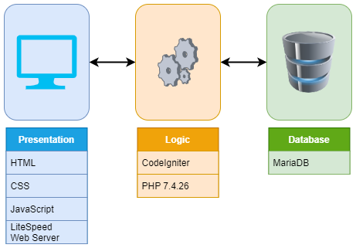

Figure 1 - Web Architecture

The web application operates on a 3-tier web architecture and uses technologies such as LiteSpeed Web Server, CodeIgniter, JavaScript libraries, and MariaDB. The programming languages mainly used were JavaScript and PHP. It was built using CodeIgniter PHP framework along with Select2 and jQuery. Moreover, it is protected by LiteSpeed Technologies Web Application Firewall (WAF) and hosted on the cloud using web-hosting.com, which is an online service that allows for publication of website files onto the Internet. The WAF implemented provided security for the web application to a certain extent. It was discovered that after sending numerous requests, the IP address of the source would be blocked and would require a reCAPTCHA to be completed on the browser to unblock it.

Through scanning the server running the web application, the hostname of the server was found to be server234.web-hosting.com, using the IP address 198.54.115.179. The operating system was discovered to be Linux using LiteSpeed Web Server, along with multiple ports opened which are well-known for file transfer, mail exchange, and web services. Some of the services were also found to contain vulnerabilities. Additionally, no HTTP methods allowed were shown such as PUT, TRACE, and DELETE.

Using automated tools, the web application was discovered to contain hidden directories that were accessible as well as interesting URLs that referenced pages that could not be seen from the User Interface. Some interesting findings were the directories “assets” and “files” as unauthenticated users can browse and view files and images that may contain sensitive information.

Based on profiling the web application, the figure below depicts the sitemap of the web application by discovering and compiling all available links and hidden directories.

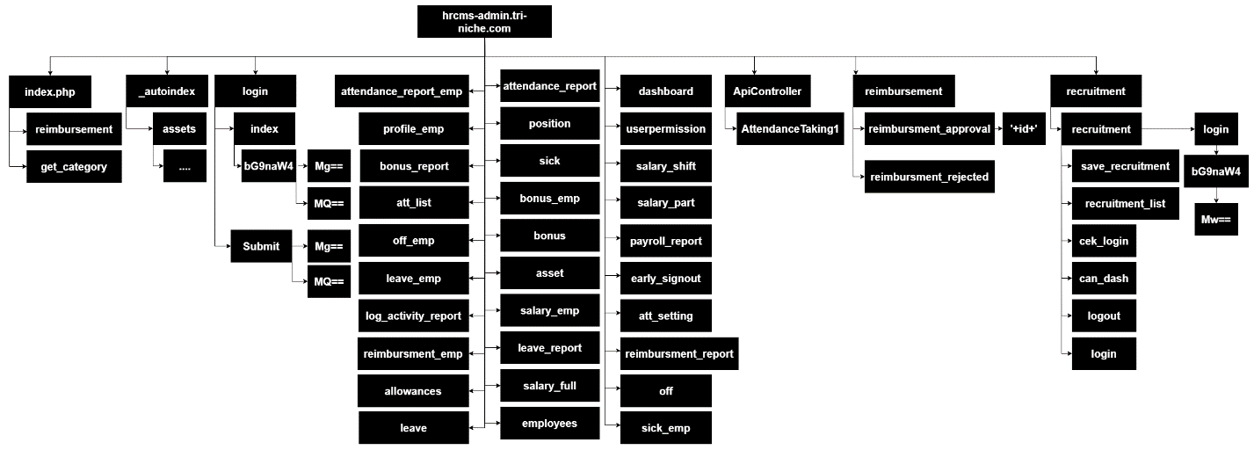

Figure 2 – Sitemap

Overall, through information gathering, potential weaknesses and misconfigurations were identified, and possible attacks can be planned after profiling the web architecture as well as the technologies used. Other attack vectors can include social engineering attacks by leveraging publicly available information on the Internet. Following information gathering, the next section would discuss the vulnerabilities discovered through various methods.

# Vulnerabilities Summary Findings

In performing a detailed vulnerability scan through the usage of automated scanning tools and manual inspections, several issues were identified. The overall web application had some security practices implemented. Nonetheless, some security flaws still exist and were discovered by the team. Throughout this section, the vulnerabilities discovered were categorized based on OWASP Top 10 2017.

The table below shows a breakdown of the vulnerabilities identified and the severity of the risk. This table is followed by a detailed description of each vulnerability. Refer to the Appendix F for the Severity Ranking Information.

Table 2 - Findings Matrix

|  |  |  |  |
| --- | --- | --- | --- |
| S/N | OWASP Top 10 | Findings | Severity Level |
| 1 | A1:2017-Injection | SQL Injection vulnerability | Critical |
| 2 | A2:2017-Broken Authentication | Authentication Brute-force vulnerability | High |
| 3 | A5:2017-Broken Access Control | Broken Access Control vulnerability | High |
| 4 | A7:2017-Cross-Site Scripting (XSS) | Cross-Site Scripting (XSS) vulnerability | High |
| 5 | A3:2017-Sensitive Data Exposure | HSTS missing from HTTPS server (RFC 6797) | Medium |
| 6 | A3:2017-Sensitive Data Exposure | FTP, POP, IMAP, and SMTP credentials transmitted unencrypted | Medium |
| 7 | A6:2017-Security Misconfiguration | X-Frame-Options Header not set | Medium |
| 8 | A6:2017-Security Misconfiguration | Browsable web directories | Low |
| 9 | A6:2017-Security Misconfiguration | Application Error Disclosure | Low |
| 10 | A7:2017-Cross-Site Scripting (XSS) | Absence of Anti-CSRF Tokens | Low |
| 11 | A9:2017-Using Components with Known Vulnerabilities | Vulnerable JS library | Low |
| 12 | A10:2017-Insufficient Logging & Monitoring | Insufficient Logging & Monitoring Vulnerability | Low |
| 13 | A6:2017-Security Misconfiguration | Web application cookies not marked secure | Informational |

The web application was tested for A3:2017-Sensitive Data Exposure, A4:2017-XML External Entities (XXE), and A8:2017-Insecure Deserialization. However, regarding XXE, no potential indicators of the stated vulnerability vector could be identified through analyzing the web application source codes. Moreover, Sensitive Data Exposure and Insecure Deserialization could not be verified due to unsuccessful attempts in identifying entry points of the researched vulnerabilities. Hence, the presence of these vulnerabilities could not be verified or identified within the web application.

## SQL Injection Vulnerability

SQL injection is a web security flaw that allows an attacker to interfere with the web application’s database queries by injecting SQL code through some method of client-supplied input. Most of the time, it allows an attacker to view data without authorization. This could include data belonging to other users or any other information that the web application has access to. In many circumstances, an attacker can modify or delete this data, causing the application’s content to be permanently altered.

|  |
| --- |
| Findings Details |
| The software constructs all or part of an SQL command but it does not neutralize special elements that could modify the intended SQL command when it is sent to a downstream component. |

Upon testing of the web application, adding an apostrophe at the end of the URL caused an unhandled error which disclosed the query used to retrieve information from the database. The database error revealed the table name, columns, and database type being MariaDB. This verifies that the web application does not have proper validation and is vulnerable to SQL injection attacks.

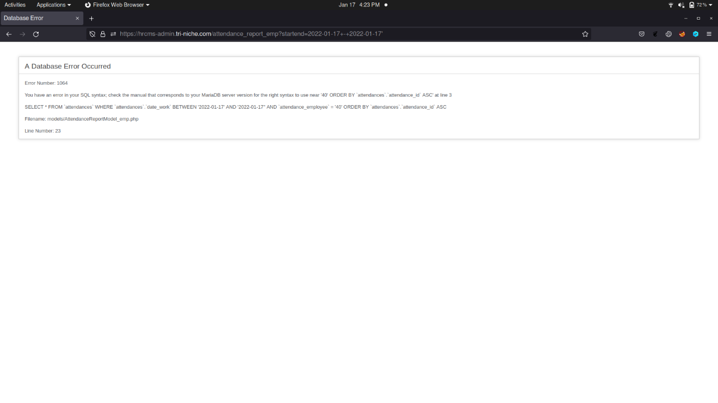

**CVE/CWE:**

CWE-89: Improper Neutralization of Special Elements used in an SQL Command ('SQL Injection')

## Authentication Brute-force Vulnerability

A brute-force attack is when an attacker uses a system of trial and error to guess a valid user’s credentials. These attacks are typically automated using a wordlist of possible usernames and passwords. Automating this process using dedicated tools enables an attacker to make vast numbers of login attempts at high speed.

|  |
| --- |
| Findings Details |
| The remote web server seems to transmit credentials using Form-based Authentication. |

When the POST request was intercepted, the username and password were sent over in plaintext. If no account policies are enforced, attackers can perform a brute-force attack until a valid password is discovered. Additionally, enumeration of valid credentials can also be performed to uncover valid user accounts.

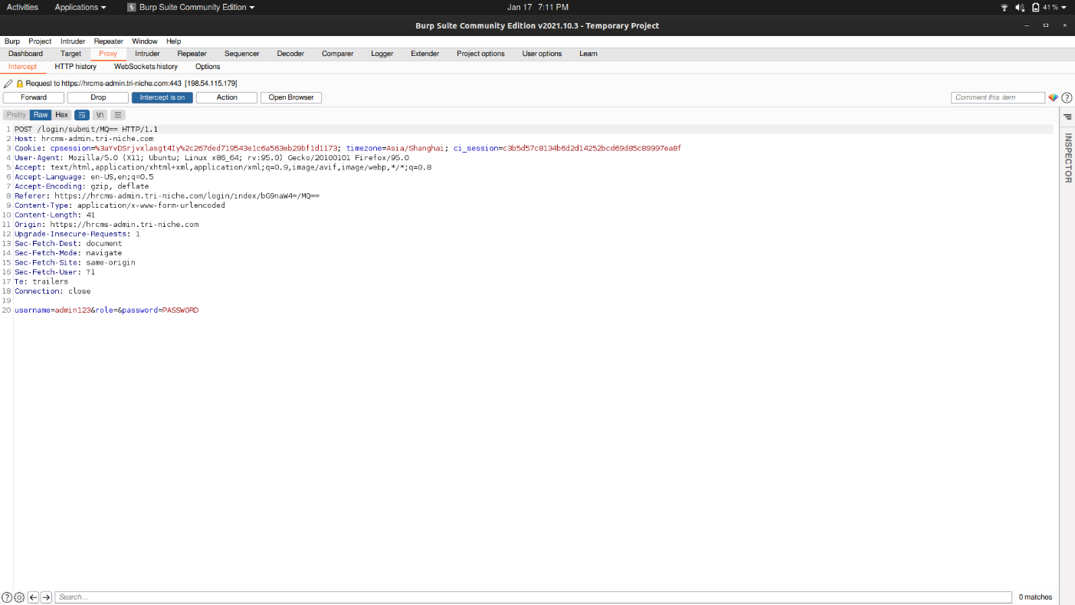

**CVE/CWE:**

CWE-307: Improper Restriction of Excessive Authentication Attempts

## Broken Access Control Vulnerability

Access control, or authorization, is the process of restricting users on which actions they can perform or which resources they can access. Hence, Broken access control is a vulnerability that is commonly encountered where users can perform actions or access resources outside of their privilege.

|  |
| --- |
| Findings Details |
| The software does not restrict or incorrectly restrict access to a resource from an unauthorized actor. |

As seen below, an employee user was granted unauthorized access to a page that is exclusive for employer users only. It was discovered that some pages had access verification, but some pages were not implemented or were implemented incorrectly.

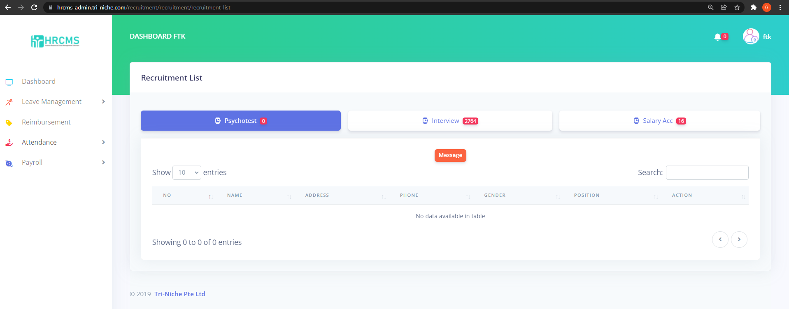

**CVE/CWE:**

CWE-284: Improper Access Control

## Cross-Site Scripting (XSS) Vulnerability

Cross-site scripting (XSS) is an attack vector that takes advantage of dynamically generated web pages. In an XSS attack, the web application is sent a script that activates when it is read by an unsuspecting user’s browser or by an application that is not protected against XSS. Because dynamic websites rely on user input, a malicious user can input malicious script into the page by hiding it within legitimate requests. These scripts can access any cookies, session tokens, or other sensitive information retained by the browser and used for that site. It can also rewrite the contents of the web page.

|  |
| --- |
| Findings Details |
| The software does not neutralize or incorrectly neutralizes user-controllable input before it is placed in output that is used as a web page that is served to other users. |

The web application is discovered to be quite secured against XSS attacks with the presence of a Web Application Firewall (WAF). Despite that, one entry point was discovered which was not verified by the WAF and allowed JavaScript elements to be stored in the database. Since no output sanitization was implemented either, as seen below, an alert was executed on the client-side browser upon testing this vulnerability.

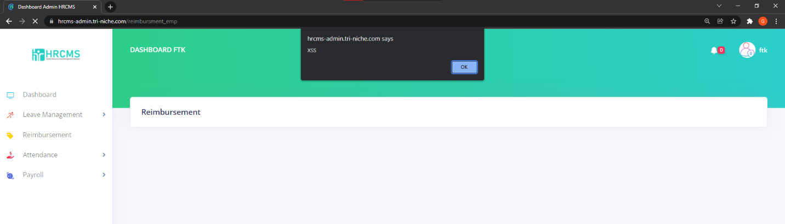

**CVE/CWE:**

CWE-79: Improper Neutralization of Input During Web Page Generation ('Cross-site Scripting')

## HSTS Missing from HTTPS Server

The remote HTTPS server is not enforcing HTTP Strict Transport Security (HSTS). HSTS is an optional response header that can be configured on the server to instruct the browser to only communicate via HTTPS. The lack of HSTS allows downgrade attacks, SSL-stripping, man-in-the-middle attacks, and weakens cookie-hijacking protections.

|  |
| --- |
| Findings Details |
| The remote web server is not enforcing HSTS, as defined by RFC 6797. |

SSL stripping attacks, also known as SSL downgrade or HTTP downgrade attacks, are a type of attack in which attackers downgrade a web connection from the more secure HTTPS to the less secure HTTP. This can result in sensitive data in transit such as username and password being exposed. This vulnerability was detected by an automated scanning tool.

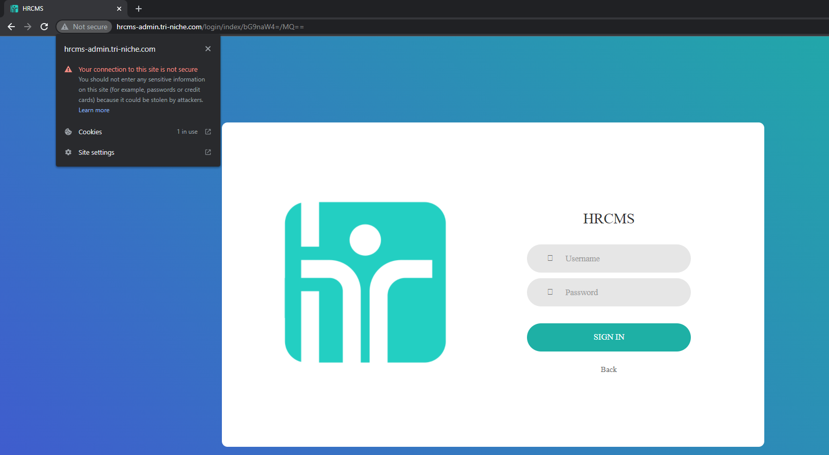

**CVE/CWE:**

CWE-523: Unprotected Transport of Credential

## FTP, POP, IMAP, and SMTP Credentials Transmitted Unencrypted

The File Transfer Protocol (FTP) is a standard communication protocol used for the transfer of computer files from a server to a client on a computer network.

Post Office Protocol (POP) is an application-layer Internet standard protocol used by e-mail clients to retrieve e-mail from a mail server.

IMAP (Internet Message Access Protocol) is an Internet protocol that synchronizes e-mail inboxes across multiple devices.

The Simple Mail Transfer Protocol (SMTP) is an Internet standard communication protocol for electronic mail transmission.

|  |
| --- |
| Findings Details |
| The server supports authentication methods in which credentials are sent in plaintext over unencrypted channels. |

If an attacker were to intercept traffic between a client and this server, the credentials would be exposed. This vulnerability was detected by an automated scanning tool.

**CVE/CWE:**

CWE-319: Cleartext Transmission of Sensitive Information

## X-Frame-Options Header Not Set

The X-Frame-Options HTTP response header can be used to indicate whether or not a browser should be allowed to render a page in certain HTML elements. When it is not set, attackers can use this to perform clickjacking attacks by embedding malicious content into the web application.

|  |
| --- |
| Findings Details |
| X-Frame-Options header is not included in the HTTP response to protect against 'Clickjacking' attacks. |

Based on the result from a security headers scanner tool, the X-Frame Options was verified to be missing. Hence it is vulnerable to Clickjacking. It is an attack that tricks a user into clicking a webpage element that is invisible or disguised as another element. This can cause users to unknowingly download malware, visit malicious web pages, provide credentials or sensitive information. This vulnerability was detected by an automated scanning tool.

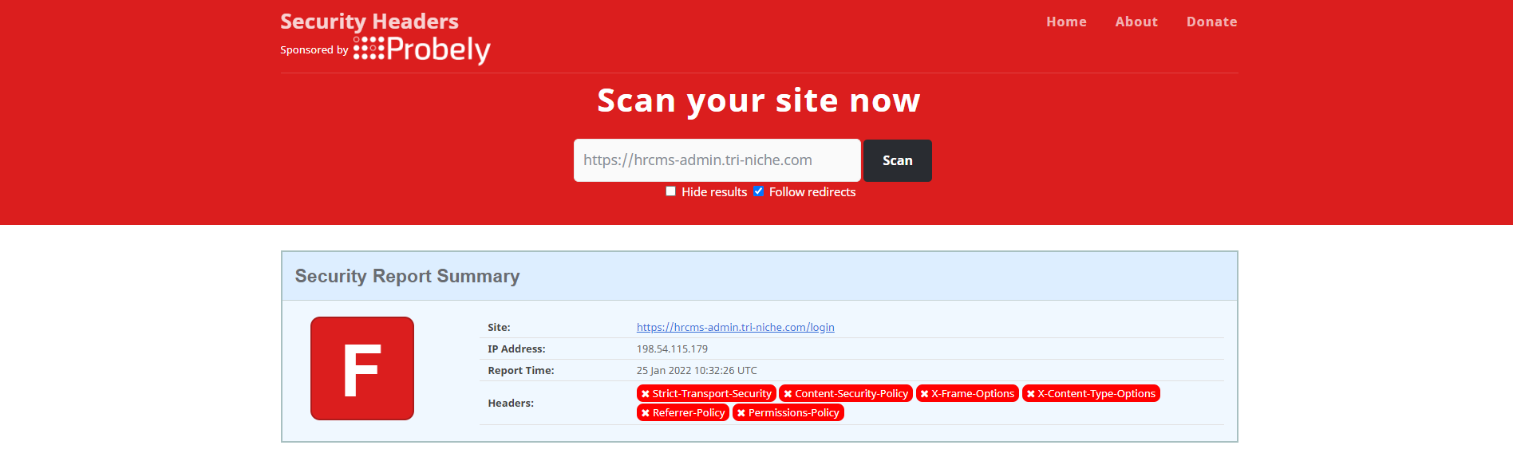

**CVE/CWE:**

CWE-1021: Improper Restriction of Rendered UI Layers or Frames

## Browsable Web Directories

Directory browsing is an information gathering attack that leverages an administrative misconfiguration in a web server that allows listing of directory contents. This is not advisable as it presents a potential threat by revealing far too much information. Most web servers are configured out-of-the-box with directory browsing turned on.

The presence of a directory listing does not always imply that it is a security risk. Any sensitive resources in the web root should be access-controlled and should not be accessible by an unauthorized person who knows or guesses the URL. Even if directory listings are blocked, an attacker can use automated techniques to estimate the location of sensitive data.

|  |
| --- |
| Findings Details |
| Some directories on the remote web server are browsable |

Although restriction measures are implemented to forbid unauthorized access to directories, certain directories were not blocked and might consist of valuable information to an attacker. As seen below, the files directory was not blocked, and the images can be viewed.

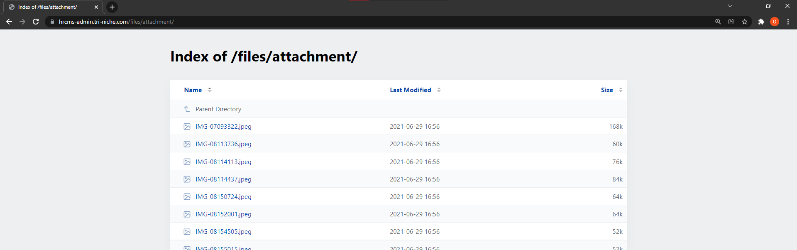

**CVE/CWE:**

CWE-548: Exposure of Information Through Directory Listing

## Application Error Disclosure

An application error disclosure is an attack where the web application reveals information that can be useful for an attacker to construct and plan attacks. The information includes information about the server environment, credentials of API keys, and many more. These leakages can have disastrous effects on the server.

|  |
| --- |
| Findings Details |
| The software contains an error or warning message that may disclose sensitive information like the location of the file that produced the unhandled exception. |

The web application contains a function that was not implemented correctly which resulted in an unhandled error exception. The error page as shown below displays the different errors which occurred, the filename, file location, and a database error that shows the table name for employees and the column names. This information can be used for further attacks against the web application, such as SQL injection using database error information.

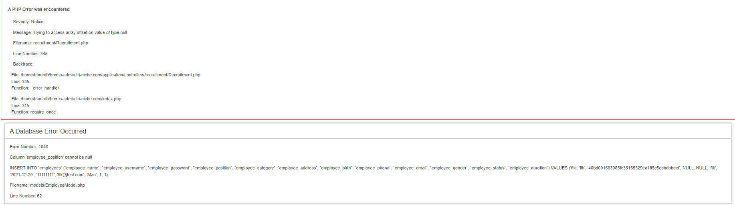

**CVE/CWE:**

CWE-200: Exposure of Sensitive Information to an Unauthorized Actor

## Absence of Anti-CSRF Tokens

Cross-Site Request Forgery (CSRF) is an attack that involves forcing a victim to send a HTTP request to a target destination without their knowledge or intent to perform actions disguised as the victim. The underlying cause is application functionality using predictable URL or form actions in a repeatable way. The nature of the attack is that CSRF exploits the trust that a website has for a user.

|  |
| --- |
| Findings Details |
| No Anti-CSRF tokens were found in a HTML submission form. |

The absence of Anti-CSRF tokens may lead to a Cross-Site Request Forgery (CSRF) attack that can result in executing a specific application action as another logged-in user, for example stealing their account by changing their email and password or silently adding a new employee user account when executed from the admin account. This vulnerability was detected by an automated scanning tool.

**CVE/CWE:**

CWE-352: Cross-Site Request Forgery (CSRF)

## Vulnerable JS Library

Some vulnerable components such as framework libraries can be identified and exploited with automated tools. The version of the JavaScript library used on the web application was detected to be vulnerable.

|  |
| --- |
| Findings Details |
| The identified library jQuery is vulnerable. |

The version was detected to be using jQuery 3.2.1. Searching through a security vulnerability data source revealed that there are multiple known security issues with that specific version. This allows attackers to pass HTML from untrusted sources and may execute untrusted code.



**CVE/CWE:**

* CVE-2020-11023
* CVE-2020-11022
* CVE-2019-11358

## Insufficient Logging & Monitoring Vulnerability

Insufficient logging and monitoring are when vital security information logs are missing, or there is a lack of adequate log format, context, storage, security, and response time to detect an event or breach. These include logs such as authentication failure, unauthorized access detected, and attempted intrusions.

|  |
| --- |
| Findings Details |
| When a security-critical event occurs, the software either does not record the event or omits important details about the event when logging it. |

After failing multiple logon attempts into admin123 account, no failed login audit logs were recorded. This can result in an attacker attempting to brute-force credentials without being detected by the web application administrator.

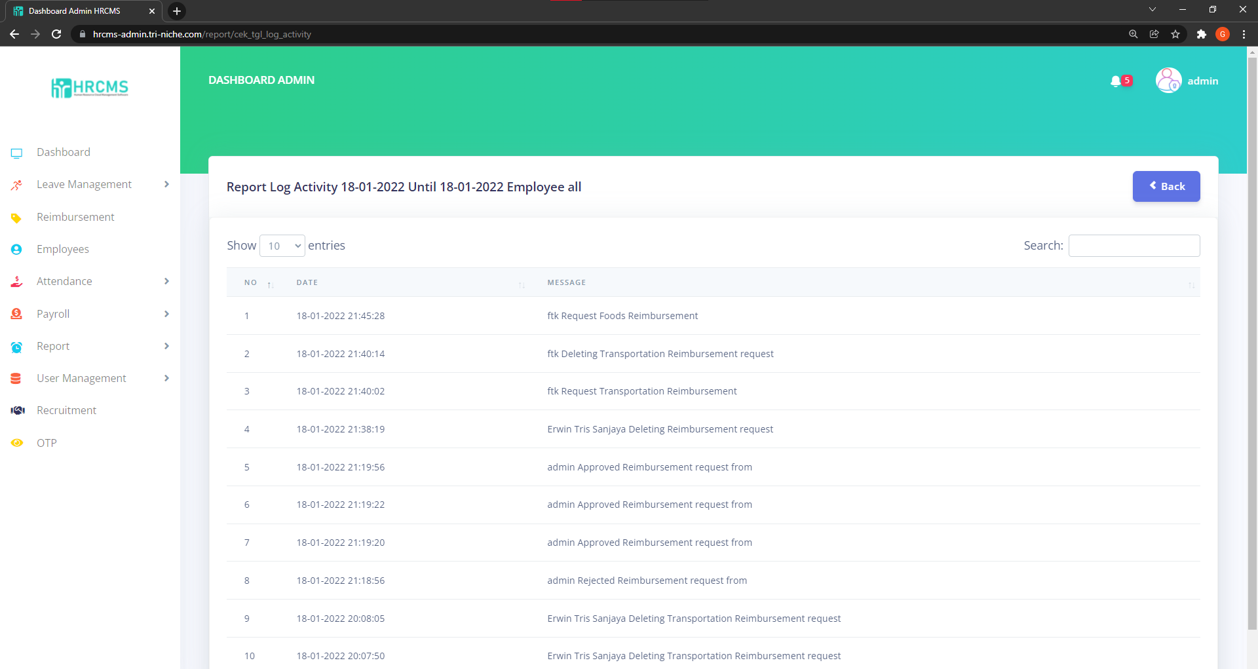

**CVE/CWE:**

CWE-778: Insufficient Logging

## Web Application Cookies Not Marked Secure

The remote web application sets various cookies throughout a user's unauthenticated and authenticated session. However, there are instances where the application is running over unencrypted HTTP or the cookies are not marked 'secure', meaning the browser could send them back over an unencrypted link under certain circumstances. As a result, it may be possible for a remote attacker to intercept these cookies.

|  |
| --- |
| Findings Details |
| HTTP session cookies might be transmitted in cleartext |

Upon accessing the web application using HTTP instead of HTTPS, the Secure attribute in the Cookie is not marked. This does not pose as a huge threat as the web application enforces HTTPS and this vulnerability is only exposed if the client accessed the web application through unsecured means.

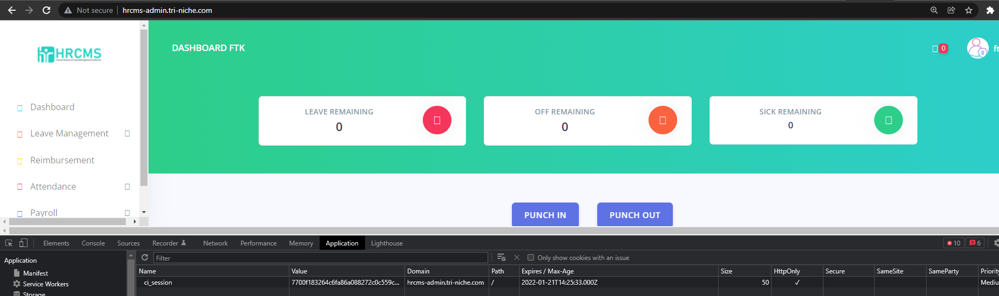

**CVE/CWE:**

CWE-522: Insufficiently Protected Credentials

# Exploitation & Post-Exploitation Summary Findings

This section summarizes the outcome during the exploitation of vulnerabilities. The vulnerabilities exploited are based on the Proof-of-Concept (PoC) use cases. Refer to Appendix E. Note that the tools used to perform the exploits would not be stated nor will the source code or payloads be provided.

## Cross-Site Scripting (XSS)

The web application contains a form that is vulnerable to XSS, and this can allow the attacker to inject malicious scripts which will be stored in the database and affect the web application. An example of a stored XSS attack is website defacement. This attack affects the availability of the web application, preventing all users from viewing the resources within that specific page. In this exploit, a website defacement attack will be emulated on the site.

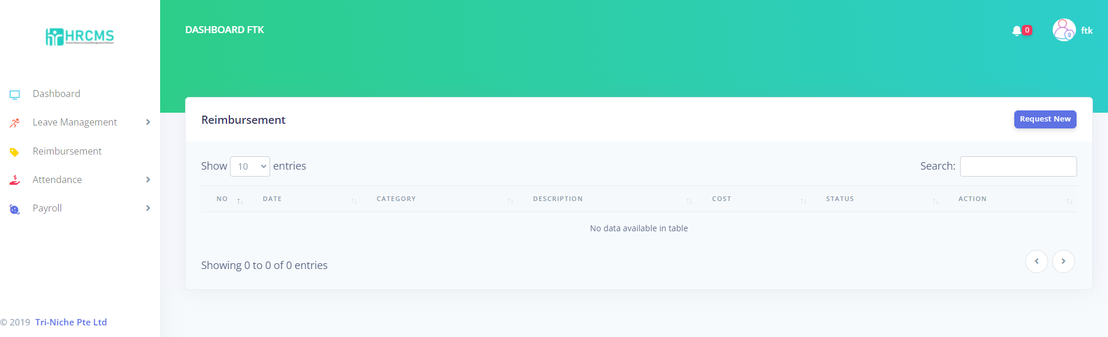

Upon submitting the malicious script, it would rewrite all contents of that specific web page and only display what was injected by the attacker. In this case, it would display the text “Web Site Defaced!” as seen below.

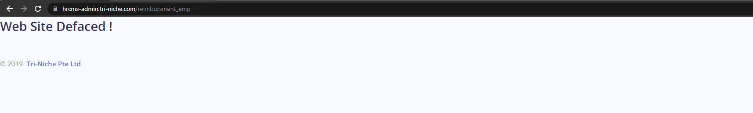

Additionally, another exploitation of XSS can be stealing credentials using a malicious login page. This is usually associated with social engineering attacks as it involves the victim entering his or her username and password onto the attacker’s website. When the form is submitted, the request with the credentials is sent over to the attacker. Upon execution of the payload, another tab would launch on the user’s browser to open a fake login page hosted on the attacker’s web server. Notice the URL that points to the attacker’s public IP address on port 1234.

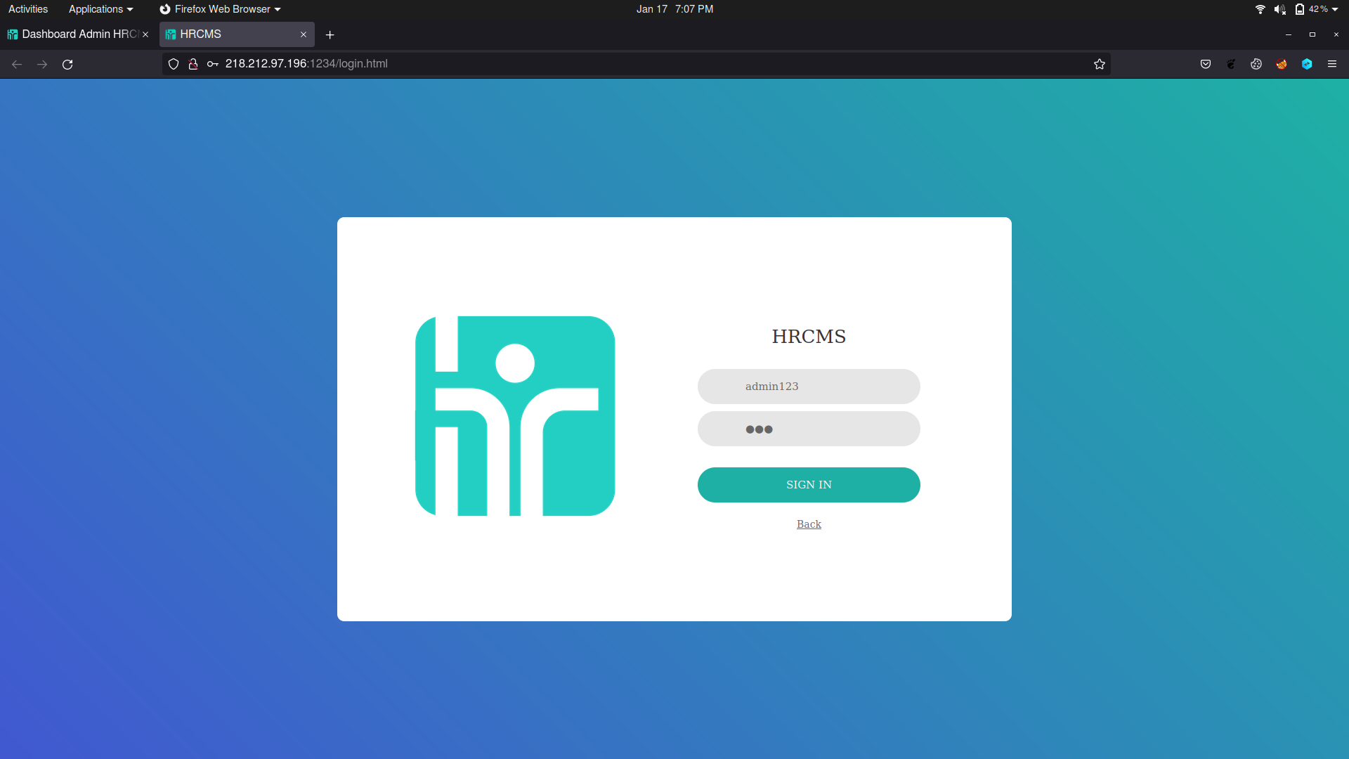

Since the reimbursement process is stored in the database where an employer can review the records, this payload would execute on the admin side as well. At this point, social engineering would occur where the administrator unknowingly enters his or her credentials into the form. As seen below, the date and time, username, and password were collected upon submission of the form.

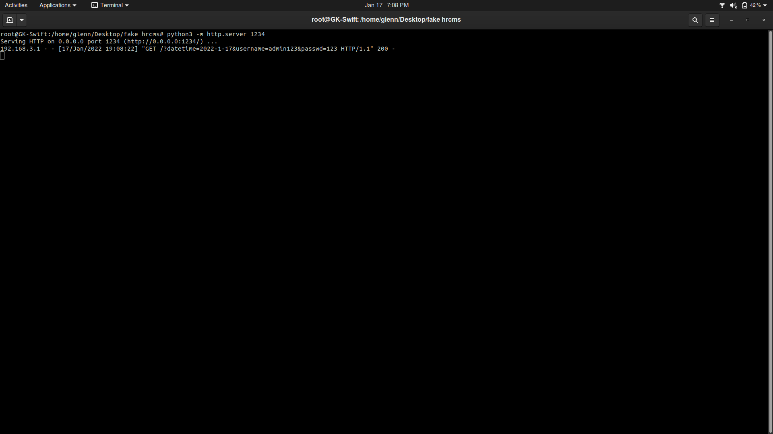

Such planned attack could lead to unsuspecting employers in the context of the web application to re-input their credentials oblivious that they are submitting their credentials to the attacker through phishing sites.

## Broken Access Control

Broken Access Control occurs when a user can access resources in an unauthorized manner which, in this case, an Employee user was able to access and perform actions on other Employee’s reimbursement data by interacting with the web application via other means.

This vulnerability impacts the availability, confidentiality, and potentially integrity of the reimbursement records. A user is able to delete another user’s reimbursement record, which affects the availability. A user is not only able to view the reimbursement record of another user but also sensitive information such as the password hash. Since the reimbursement records can be accessed by anyone, an attacker will be able to retrieve all the information stored in the reimbursement table. The information stored contains sensitive data that the attacker is able to use for further attacks such as gaining unauthorized access.

The hyperlink to delete a reimbursement record is copied with the ID modified to 167 which references another user’s reimbursement ID. In this case, object ID 167 belongs to another user, the FTK user account. When entered, no error or feedback regarding unauthorized access was shown.

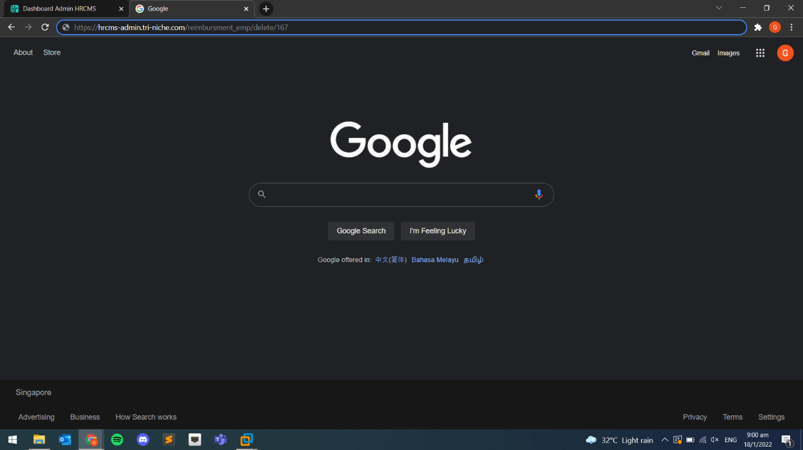

As seen, the FTK user reimbursement record was deleted in an unauthorized manner. This is highly dangerous as a script can be easily written by an attacker to enumerate and delete all records in the Reimbursement table.

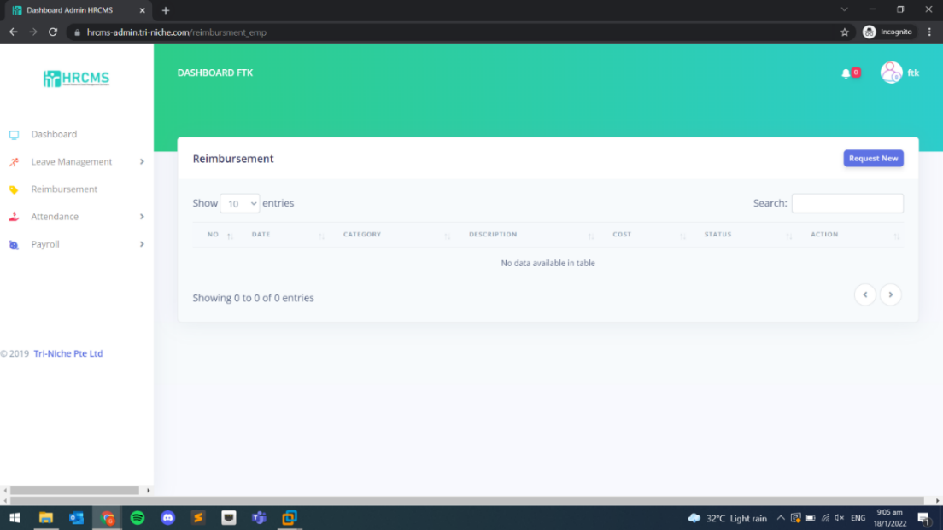

Access control to request for objects was not properly implemented. In another exploit, a user is allowed to view reimbursement records belonging to another user by modifying the hyperlink. Additionally, the records retrieved contain sensitive information. As seen below, the hyperlink revealed information about the record as well as information about the user such as the username and password hash of the user that created that record was shown.

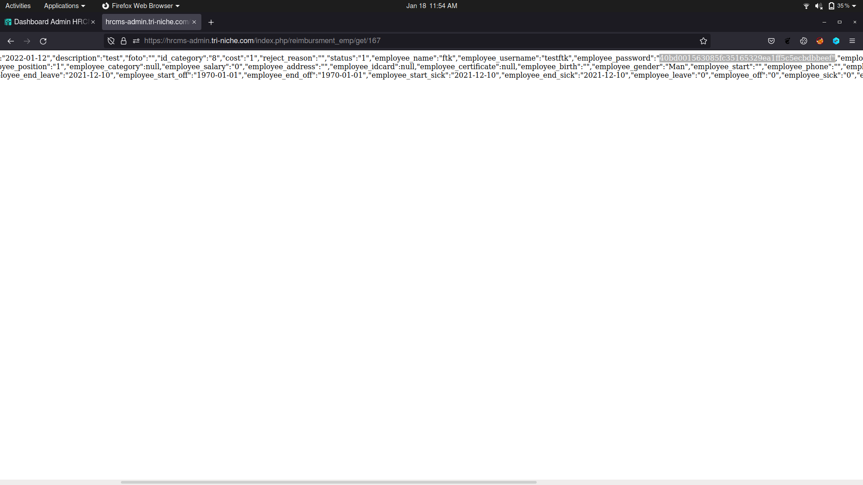

Since knowing that records can be accessed by unauthorized users, all information in the reimbursement table can be retrieved by creating a script. It works by enumerating the entries and exporting the data such as username, password, and email address which is stored on the attacker’s local directory. The output of the script is shown below where all the users that created a reimbursement entry had been exposed.

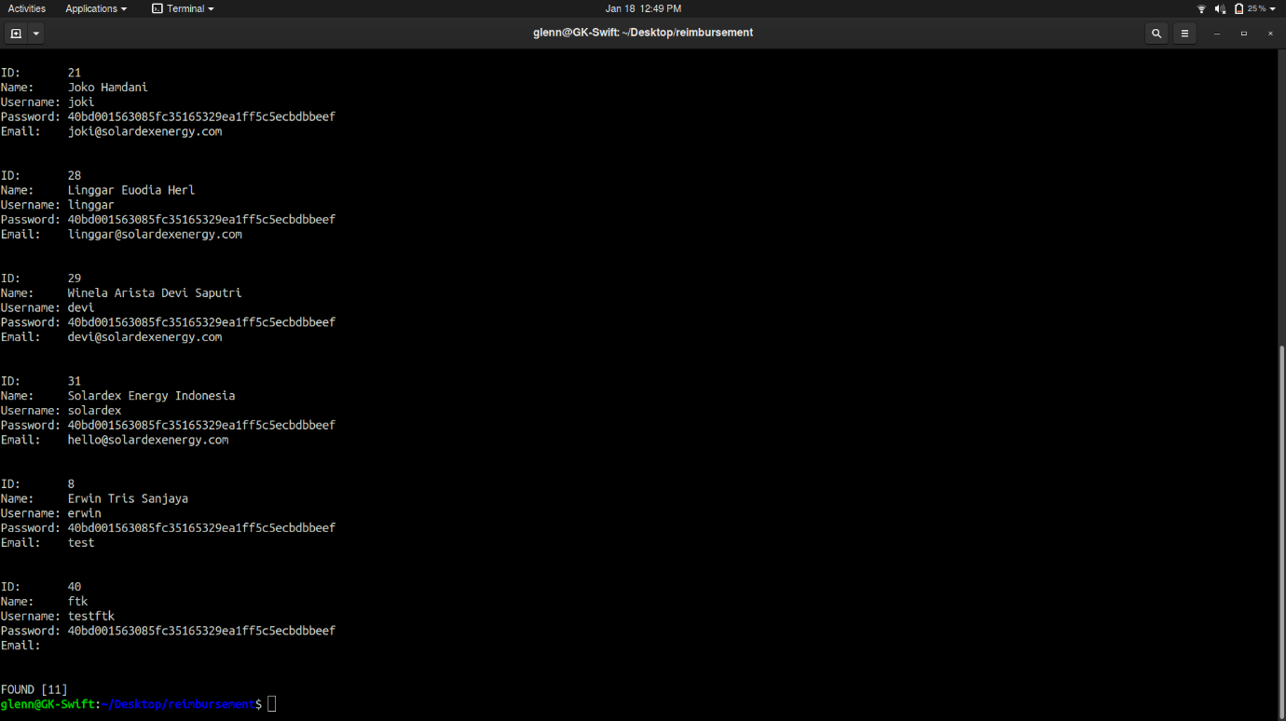

As seen below, the credentials collected are formatted into a Comma-separated Values (CSV) file which an attacker can use to gain unauthorized access.

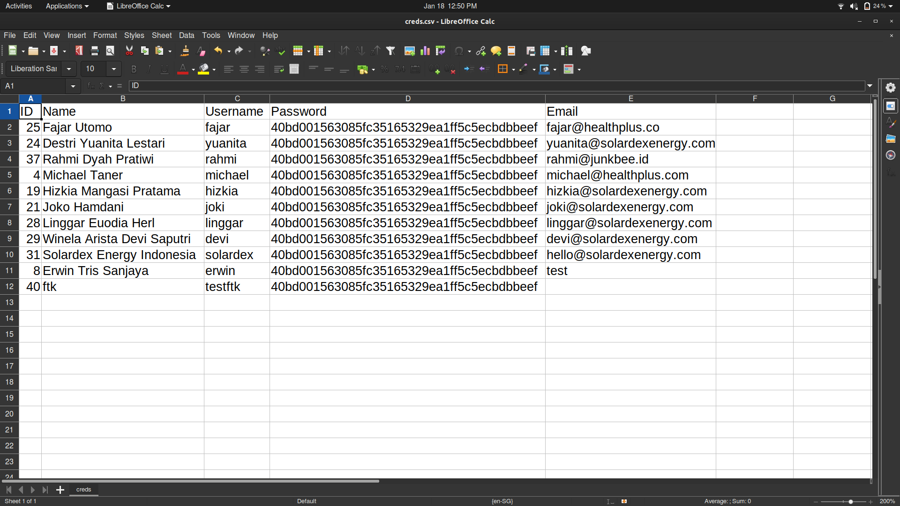

By using a tool to crack the password hashes and gain access, the user account fajar was successfully logged into by the attacker. From there, an attacker can impersonate the user and create, modify, and delete content on the web application.

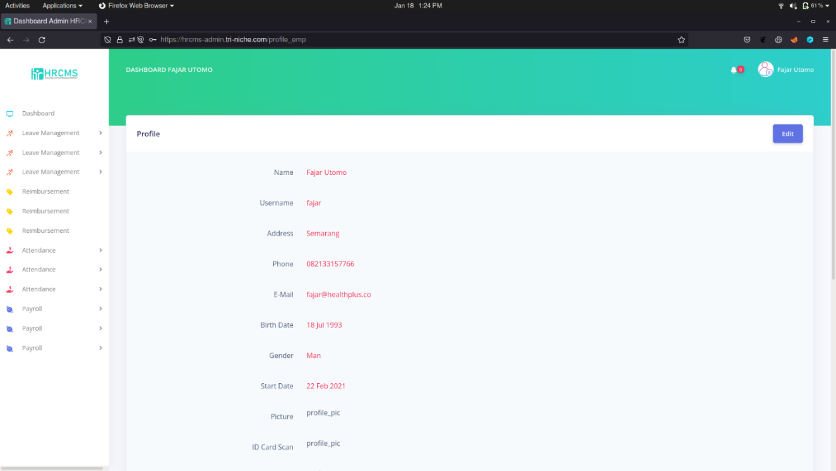

## SQL Injection

In this exploit, the attacker was able to retrieve and view users table and other relevant user’s data as part of the web application. The point of entry was identified to be a weakness in the web application due to a lack of input validation. Through the usage of an automated tool, the database of the web application was successfully enumerated, and 3 interesting databases were found.

|  |  |
| --- | --- |
| S/N | Databases Found |
| 1 | trindrdb_hrcms |
| 2 | trindrdb_hrcms2 |
| 3 | trindrdb_triniche_hrafg |

The second database was discovered to have tables that contain information about users within the database. Enumeration of the attributes of that table revealed that columns such as username, password, and user_id were shown. Upon retrieving the contents of the table, the information of users was extracted as shown below. Based on the result, the status indicates whether an account is active or has been deactivated while the level indicates whether the account has administrative privilege.

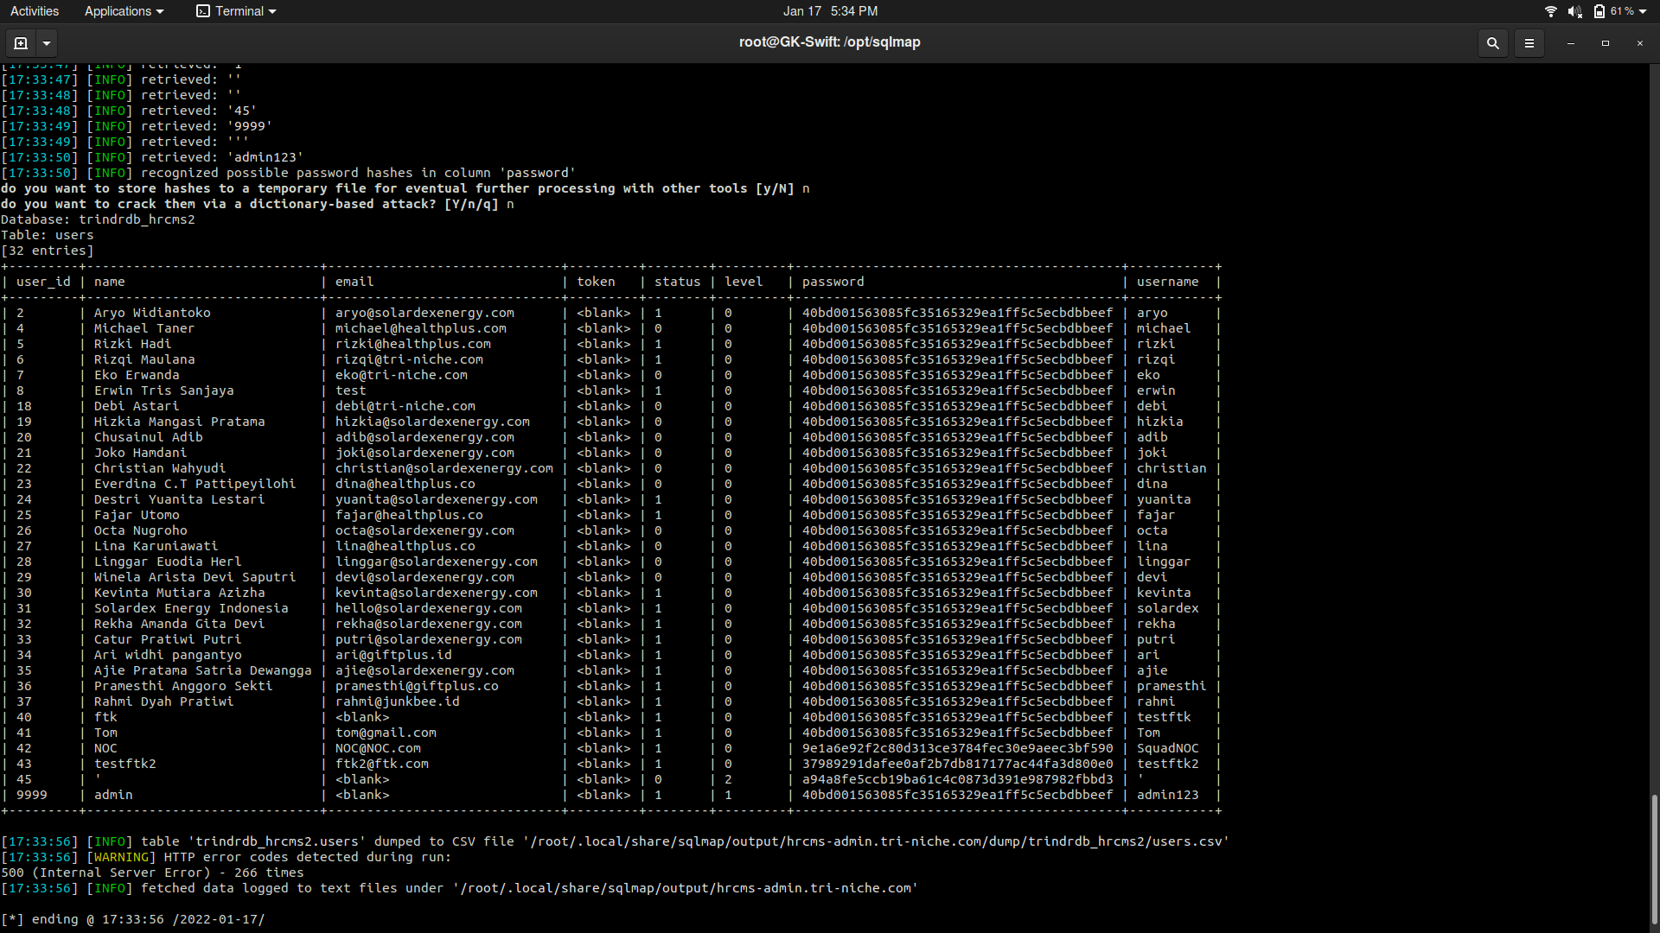

Similar to the method used in Broken Access Control, the password hash can be easily cracked to gain unauthorized access into the user account. As seen below, the attacker successfully logged into the user account aryo.

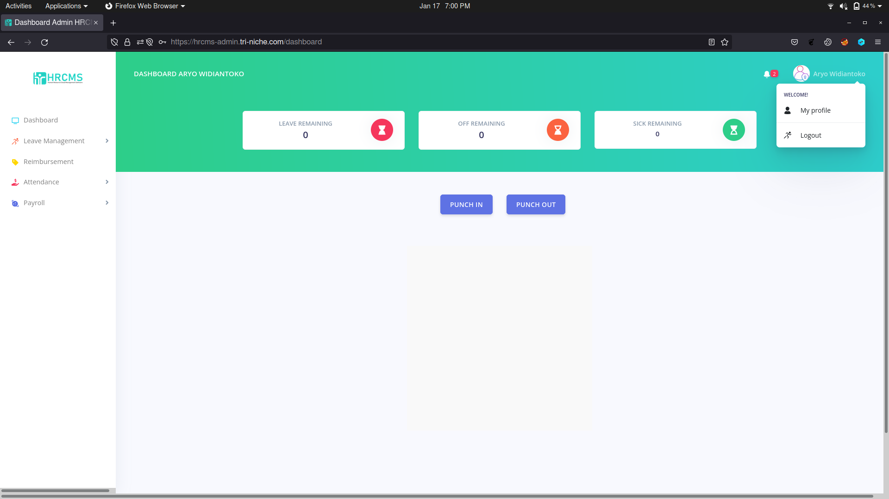

In addition, the contents of the employees table in the second database were also retrieved as shown below. Based on the result, it is similar to the Users table, but the admin account was not present.

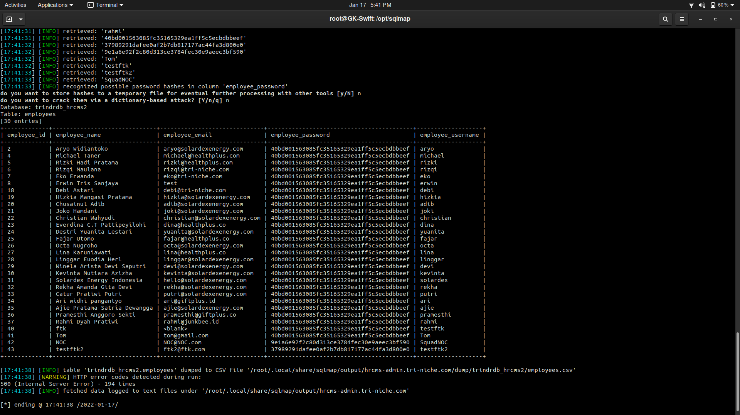

Since the information was dumped, it would automatically create a CSV file containing the information that was retrieved earlier. As seen below, it created and formatted users.csv. Attackers can easily leverage or create a program to crack the passwords and publicly disclose the information.

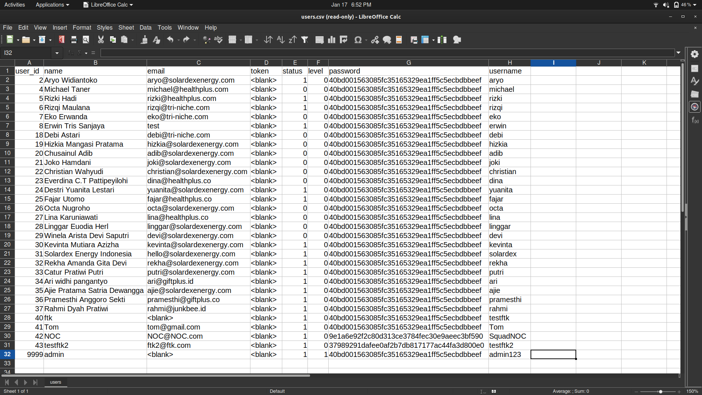

## Broken Authentication

Broken authentication occurs when there is insufficient session or credential management or both. Credential management is where user credentials are managed such as restricting and allowing users to log in to the account. An attacker can brute force the login page to gain unauthorized access into the user account. Moreover, due to insufficient logging and monitoring, the attack was undetected. This vulnerability affects the organization’s management and data.

For this exploit, an attempt to brute force a user’s account in this case an employer user who most definitely has a higher privilege making the user account a target for the exploit. In this exploit, it is made aware that the username for the Employer is ‘admin123’.

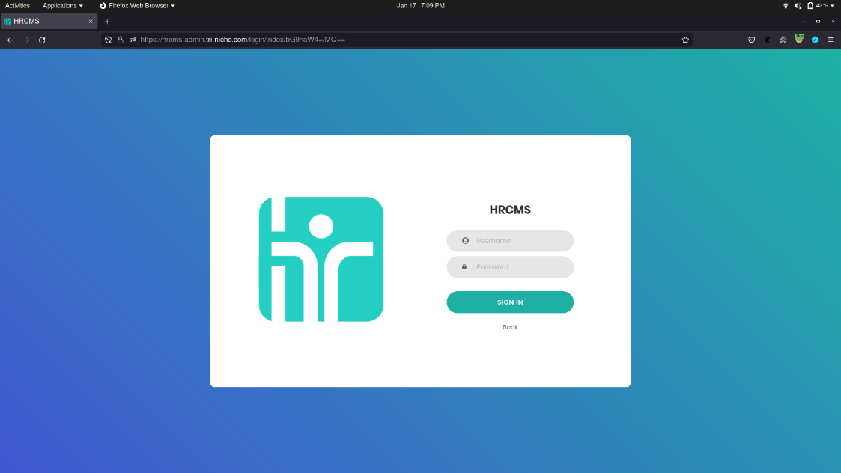

After the request was intercepted, it can be understood that there are username and password input fields at the bottom since using form-based authentication. The password field highlighted at the bottom is where the payload to brute force login attempts will be carried out.

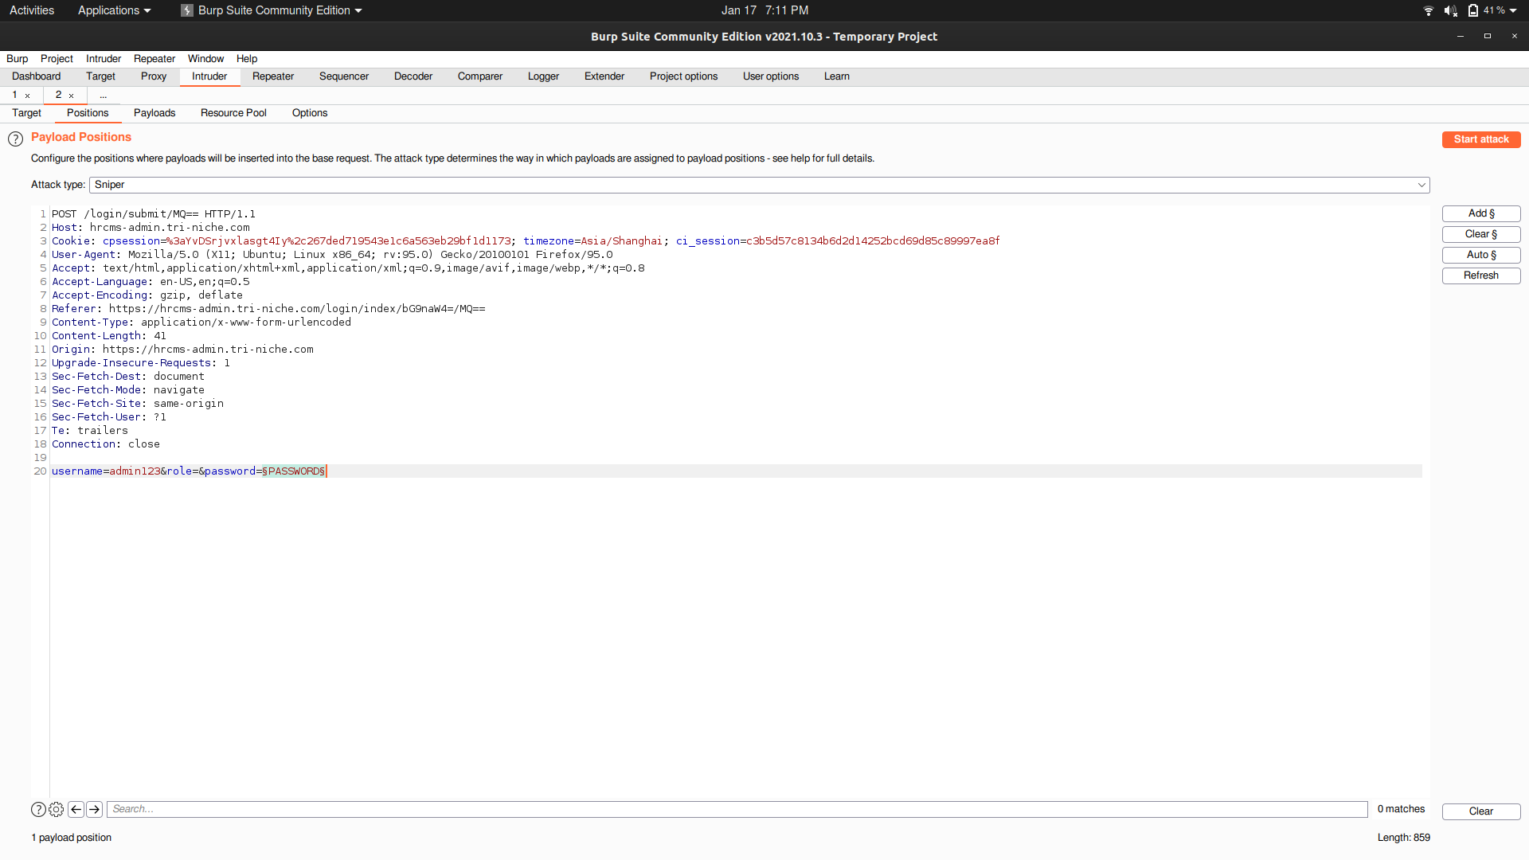

After getting hold of a password list, a brute force attempt until a 200-success request is shown. If it is not shown, the user’s password is not in the list and a larger and more extensive list can be used. Status 200 represents that the request was successful. In this case, the password is ‘123’ as can be seen below.

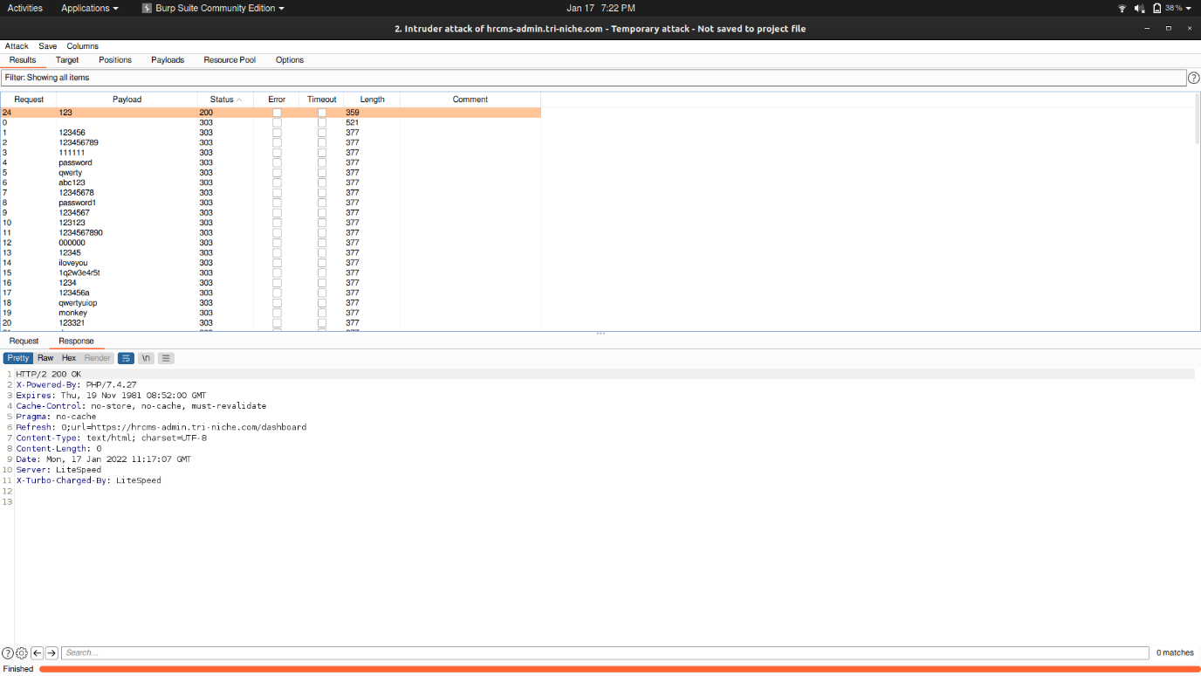

In this way, attackers can attempt to login into a user in an unauthenticated fashion without locking the account after too many logins attempts as demonstrated. As a result, the user credentials can be obtained in a trial-and-error fashion allowing attackers to sabotage organizational management and data.

## Unrestricted File Upload

There is a file upload feature present on the user profile editing page. This feature can be subjected to unrestricted file upload where attackers can upload malicious files onto the web application and gain unauthorized access such as through web shell or remote code execution.

A PHP file containing a malicious script was uploaded into the web application. The malicious script would allow the attacker to launch a web shell and run commands on the web application server to access sensitive data stored locally on the remote server. However, the file upload was blocked. Some possible explanations could be because of the web application firewall (WAF), or that only files with extensions such as ‘.jpeg’ and ‘.png’ are accepted.

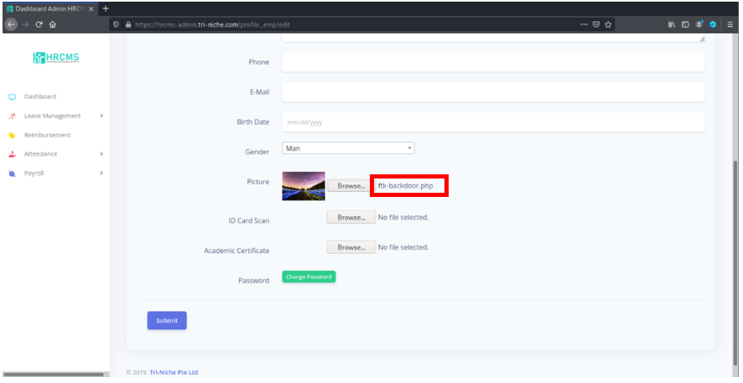

Trying to bypass the restriction by the double extension method, the malicious file was renamed to ‘ftk-backdoor.php.png’. Since the web application accepts ‘.png’. extension files, this might permit the PHP script to be successfully uploaded into the web application and allow the malicious script to run giving the attacker backdoor access.

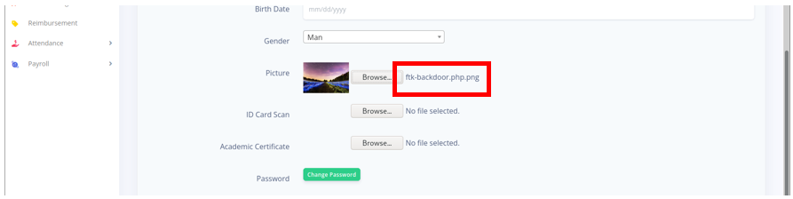

The file upload was still blocked by the web application firewall. This means that the web application checks the file uploaded for any malicious scripts instead of just the file extension. This mitigates the risk of an attacker uploading any malicious scripts hidden within files into the web application server. Hence, this exploitation was unsuccessful.

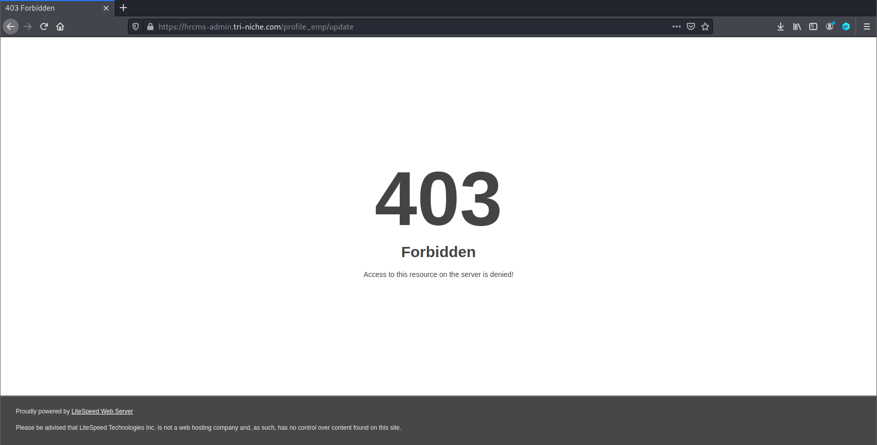

# Recommendations

This section addresses the recommended solutions to resolve the vulnerabilities discovered.

|  |
| --- |
| SQL Injection |
| Implement input validation on the server-side, and client-side if possible. Also, usage of parameterized SQL Query to protect the web application from injection attacks. It is important that the database can recognize the code and distinguish it from input data. |

|  |
| --- |
| Authentication Brute-force |
| If possible, implement multi-factor authentication to prevent automated, credential stuffing, brute force, and stolen credential re-use attacks. Additionally, it is highly recommended to implement account lockout policies and enforce strong password requirements. |

|  |
| --- |
| Broken Access Control |
| Implement access control in such a way that not all users can gain access to the resources and functionalities unless it is intended to be publicly accessible. Verify authorization of the user on the server-side before allowing access to sensitive data or performing certain actions. |

|  |
| --- |
| Cross-Site Scripting (XSS) |
| Never trust user-supplied input. Always validate input on the client-side as well as the server-side. Input and output sanitization can ensure malicious scripts are not executed on the client-side. |

|  |
| --- |
| HSTS Missing from HTTPS Server |
| Enforce SSL use for the login page or any page used to transmit user credentials or other sensitive information. |

|  |
| --- |
| FTP, POP, IMAP, and SMTP Credentials Transmitted Unencrypted |
| Encrypt the data with a reliable encryption scheme before transmitting. |

|  |
| --- |
| X-Frame-Options Header Not Set |
| The use of X-Frame-Options allows developers of web content to restrict the usage of their application within the form of overlays, frames, or iframes. The developer can indicate from which domains can frame the content. |

|  |
| --- |
| Browsable Web Directories |
| Configure your webserver to prevent directory listings for all paths beneath the web root. |

|  |
| --- |
| Application Error Disclosure |
| Uncaught exceptions must be handled, and error messages displayed should be non-verbose. |

|  |
| --- |
| Absence of Anti-CSRF Tokens |
| Usage of a vetted library or framework that does not allow this weakness to occur or provides constructs that make this weakness easier to avoid. |

|  |
| --- |
| Vulnerable JS Library |
| Remove libraries that are no longer in use to reduce the attack surface. Frequently check for patches and upgrade JavaScript libraries to the latest version. |

|  |
| --- |
| Insufficient Logging & Monitoring Vulnerability |
| Use a centralized logging mechanism that supports multiple levels of detail. Ensure that all security-related successes and failures can be logged. |

|  |
| --- |
| Web Application Cookies Not Marked Secure |
| Use an appropriate security mechanism to protect the credentials. |

# Summary

Team FTK, from the School of InfoComm Technology, Ngee Ann Polytechnic has completed the penetration testing of the HRCMS-Admin web application. This testing was based on the technologies and known threats as of the date of this document. All security issues discovered during the exercise were analyzed and described in this report.

Overall, a reasonable level of security has been attained by the web application. In this report, a summary of information gathering, vulnerabilities findings, and exploitation was documented. The vulnerabilities discovered were focused on the OWASP Top Ten Web Application Security Vulnerabilities (2017) as well as other possible known attack vectors. These vulnerabilities were found by performing a combination of automated and manual testing. The most severe vulnerabilities that can impact the confidentiality, integrity, and availability of the web application were exploited. The outcome of the exploitations includes disruption of service, disclosure of sensitive information, and obtaining login credentials of valid users.

Please note that as technologies and risks change over time, the vulnerabilities associated with the operation of systems described in this report, as well as the actions necessary to reduce the exposure to such vulnerabilities will change.

# Appendices

## Signed-Off Scope Document

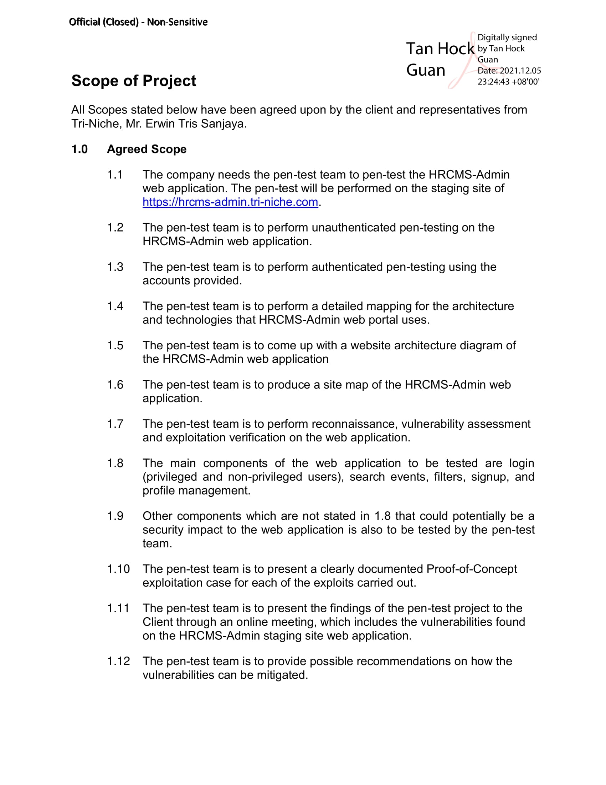

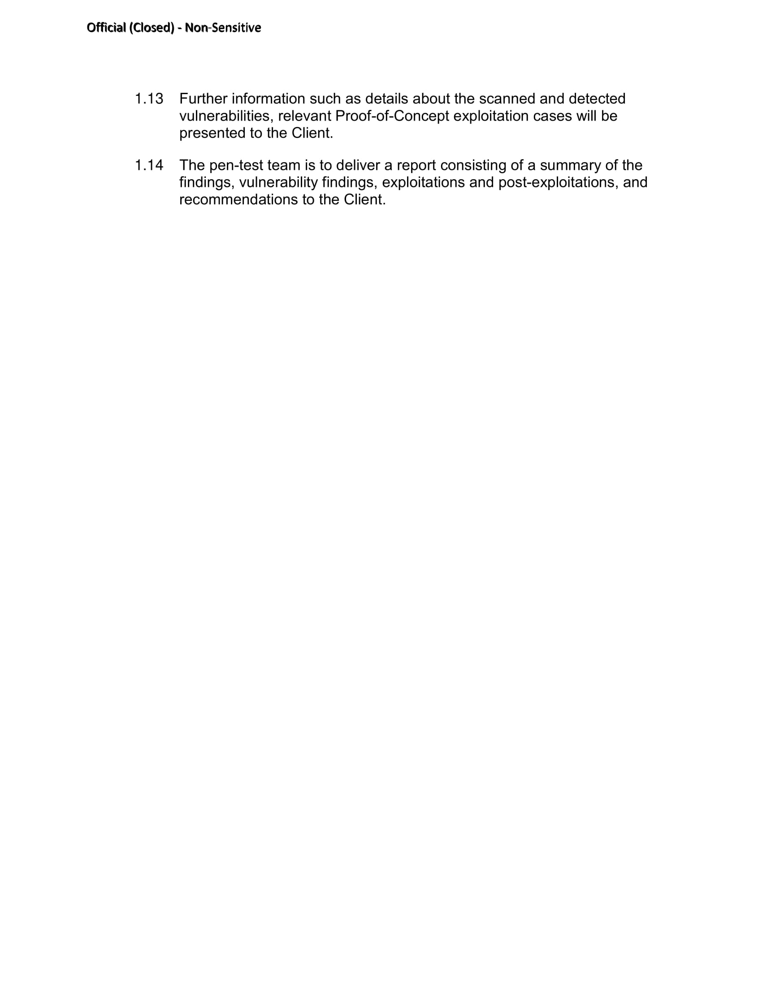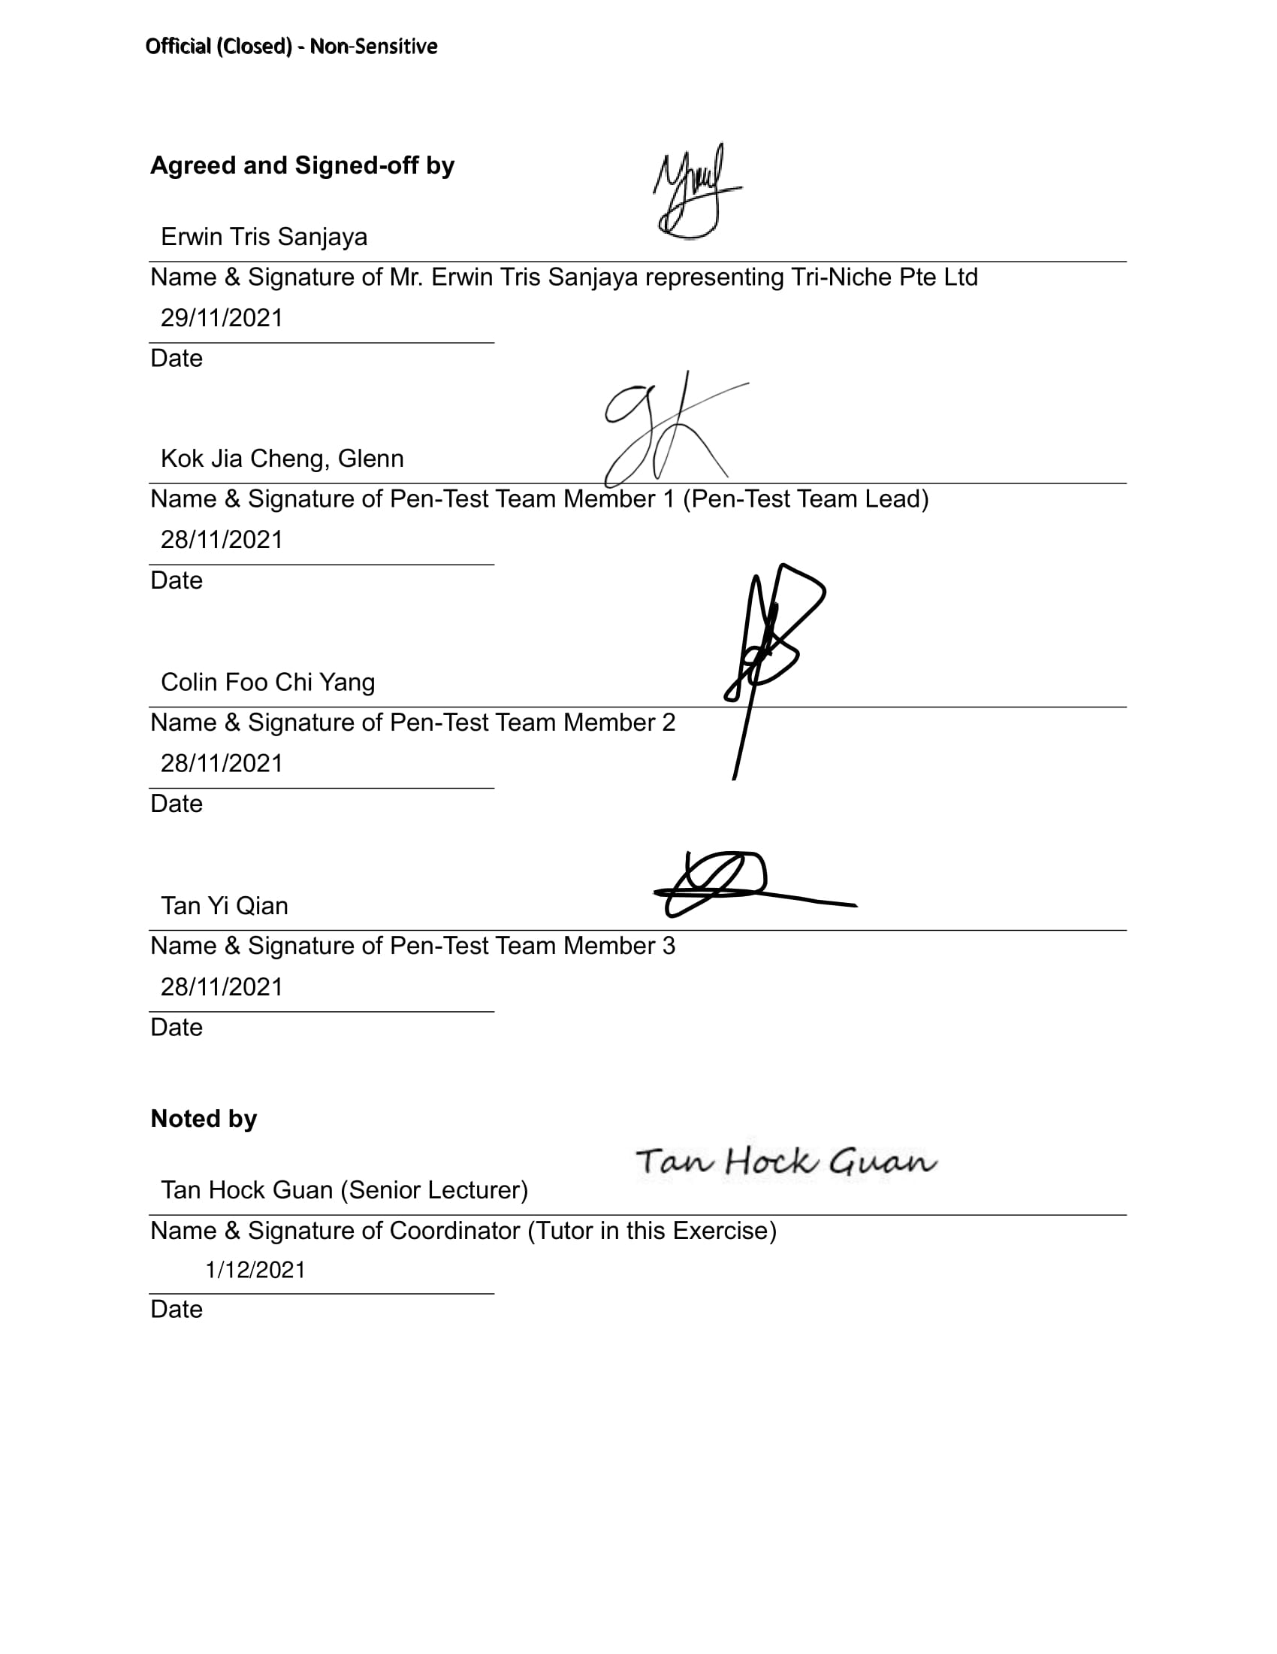

## Signed-Off Rules of Engagement Document

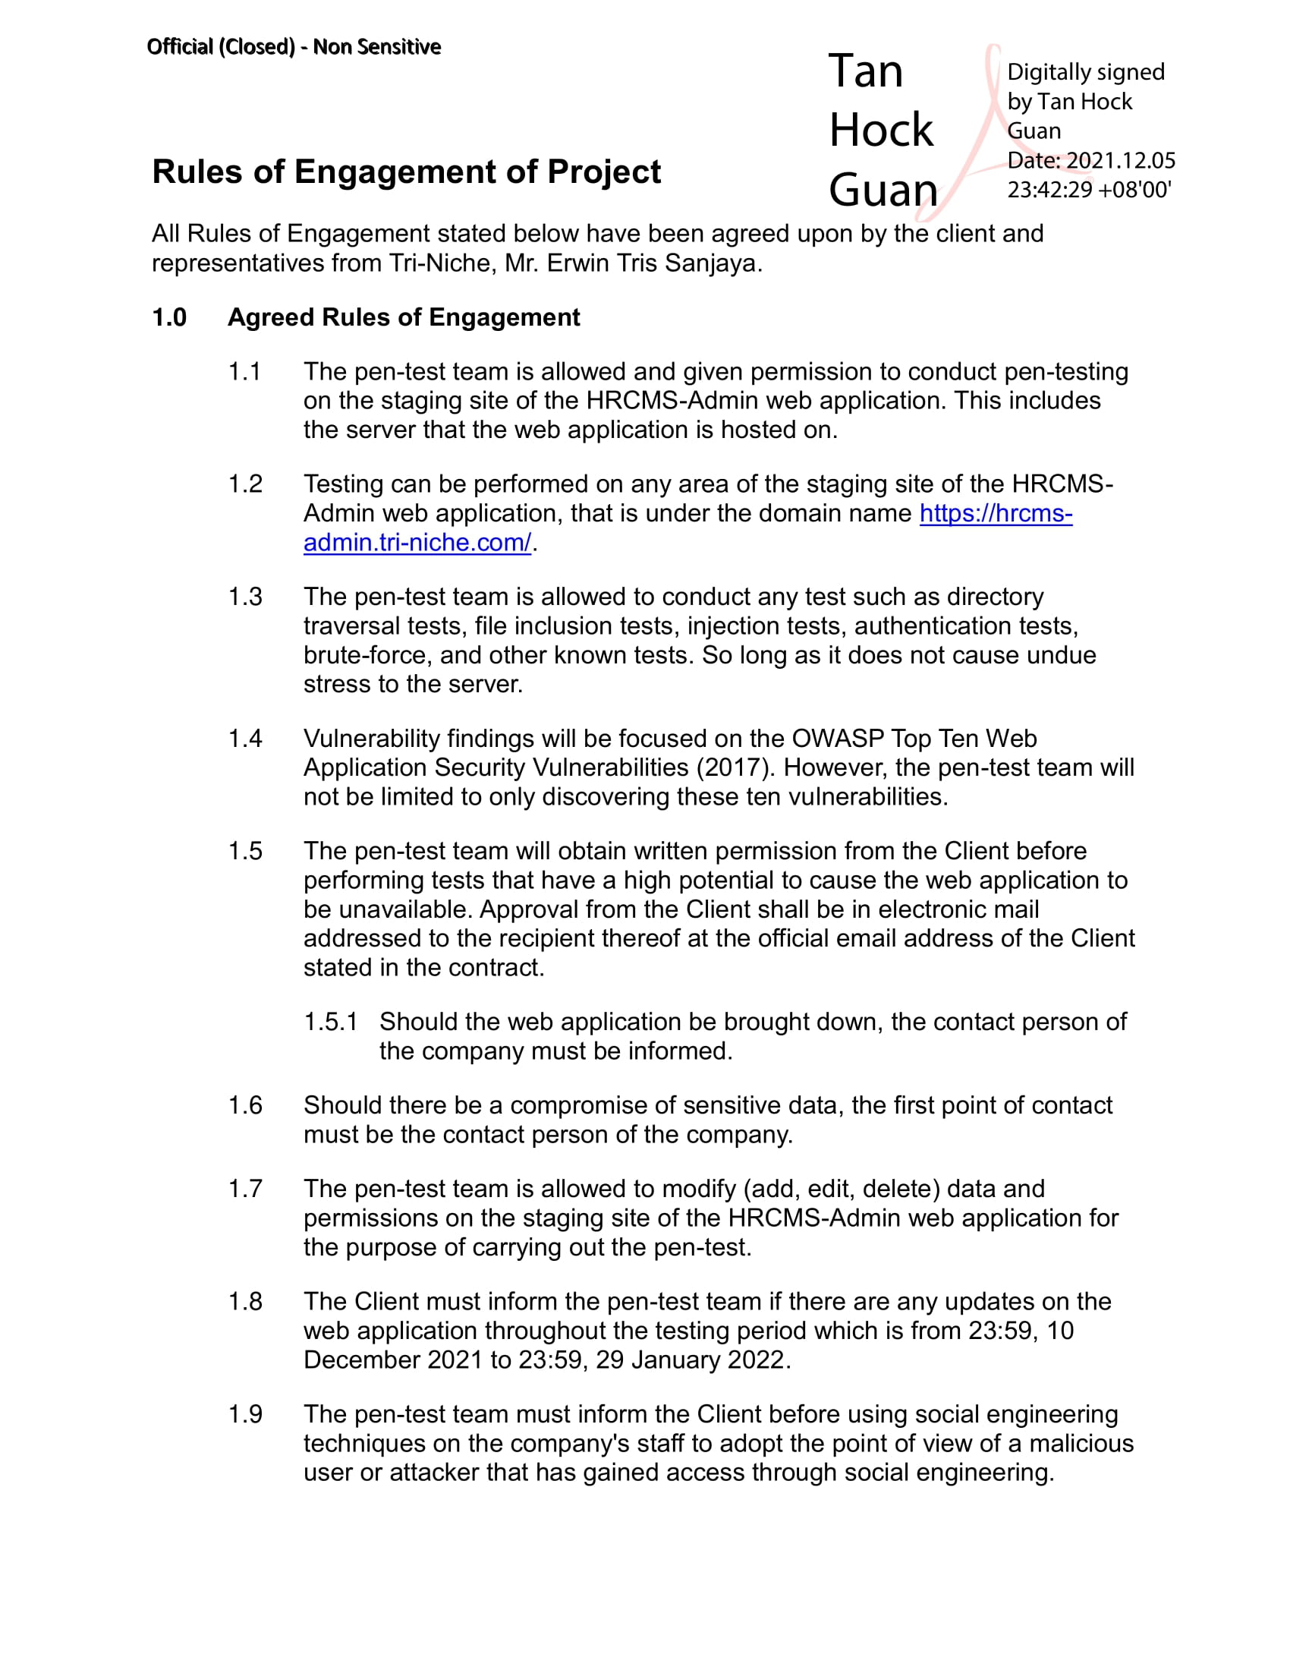

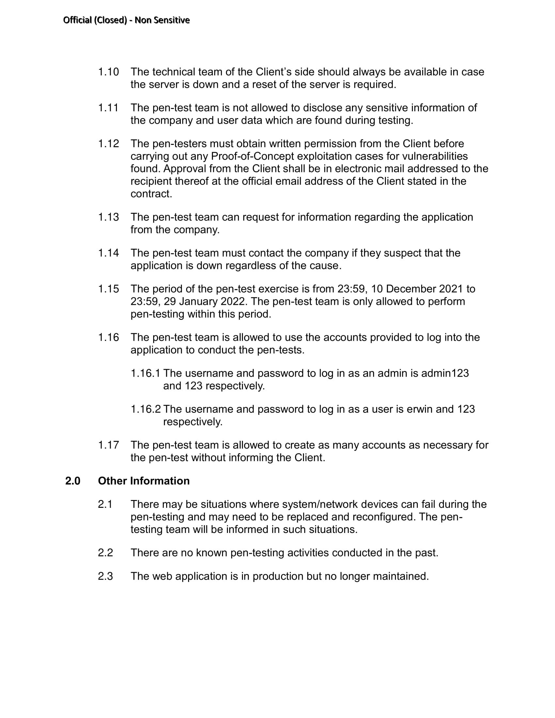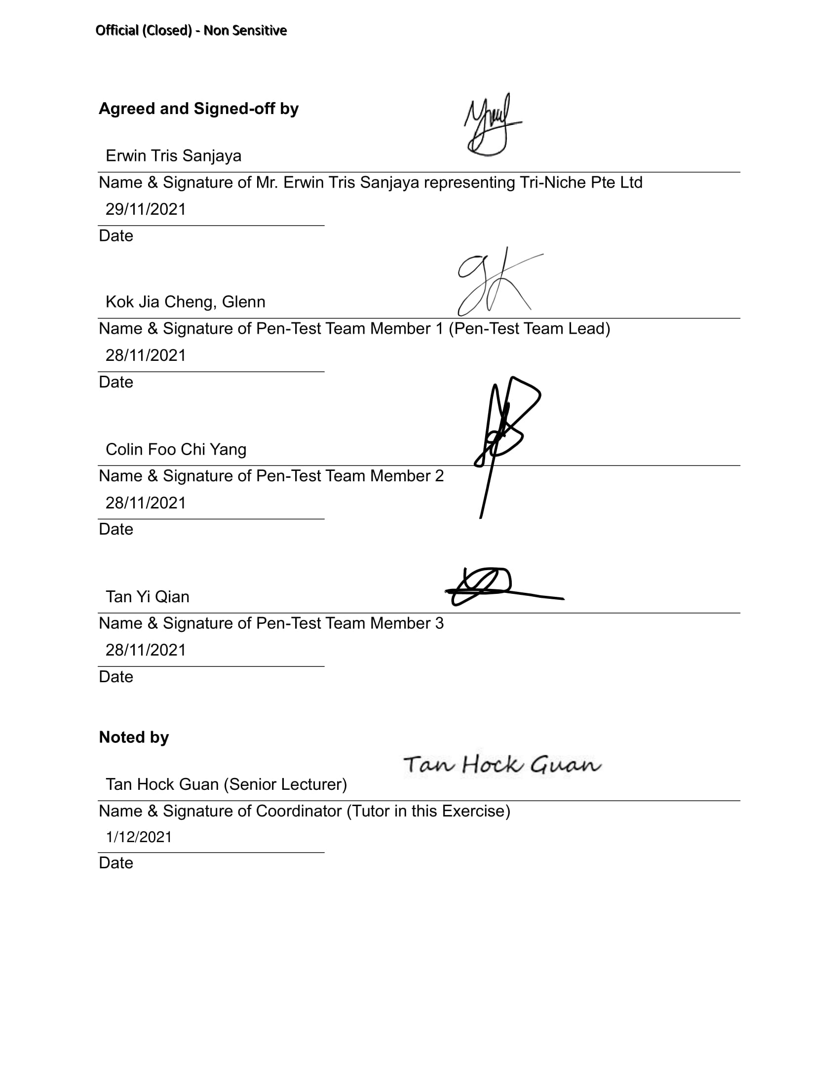

## Signed-Off Agreement/Contract

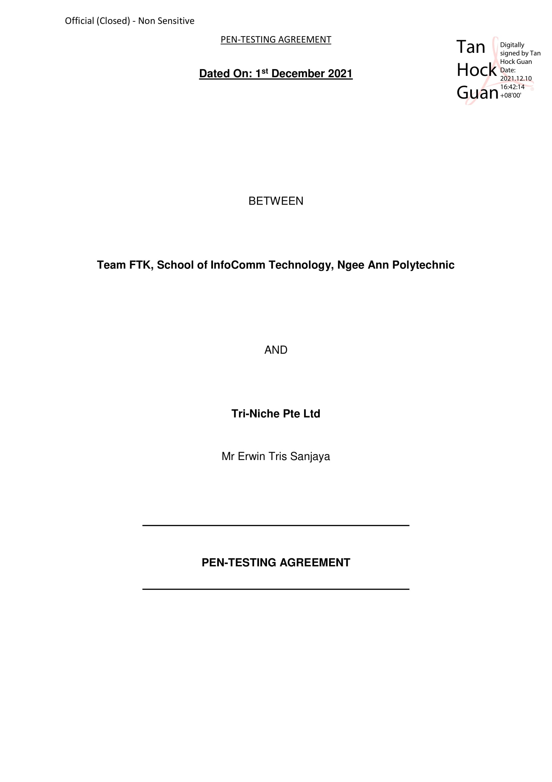

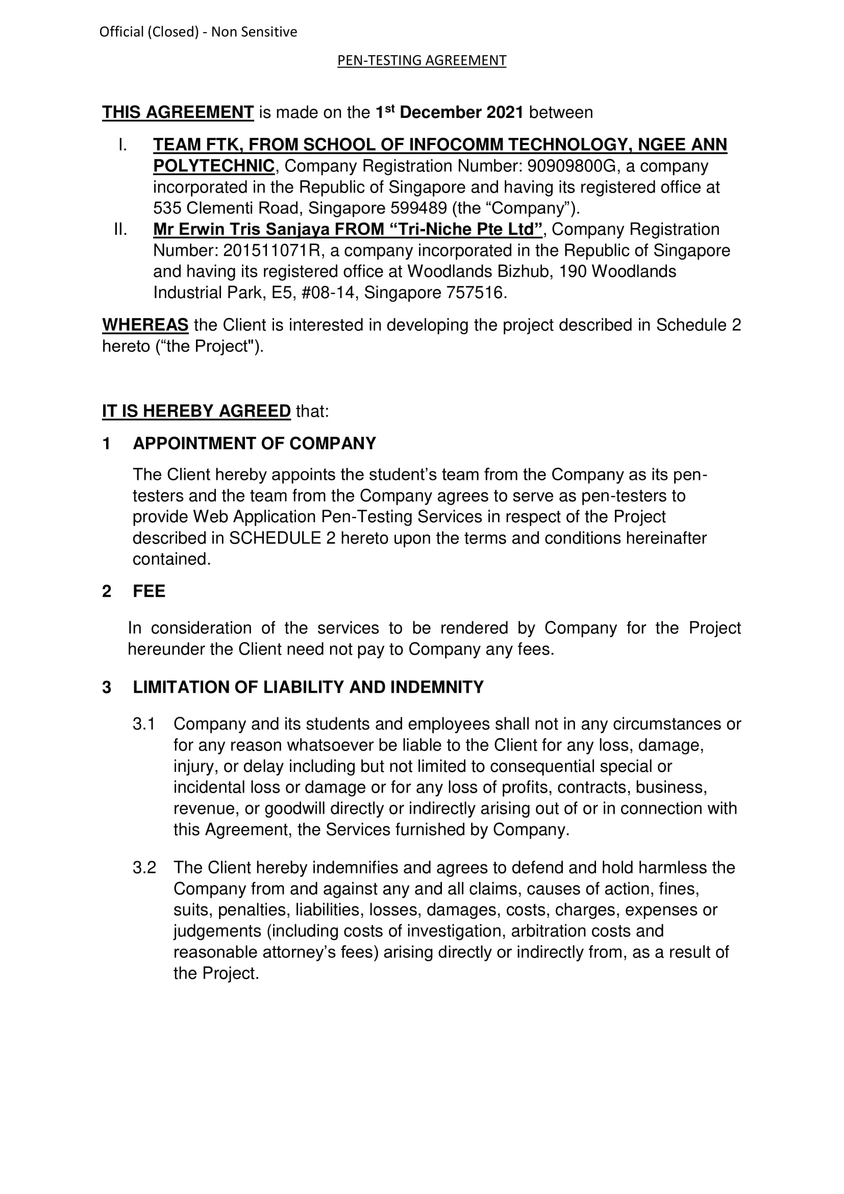

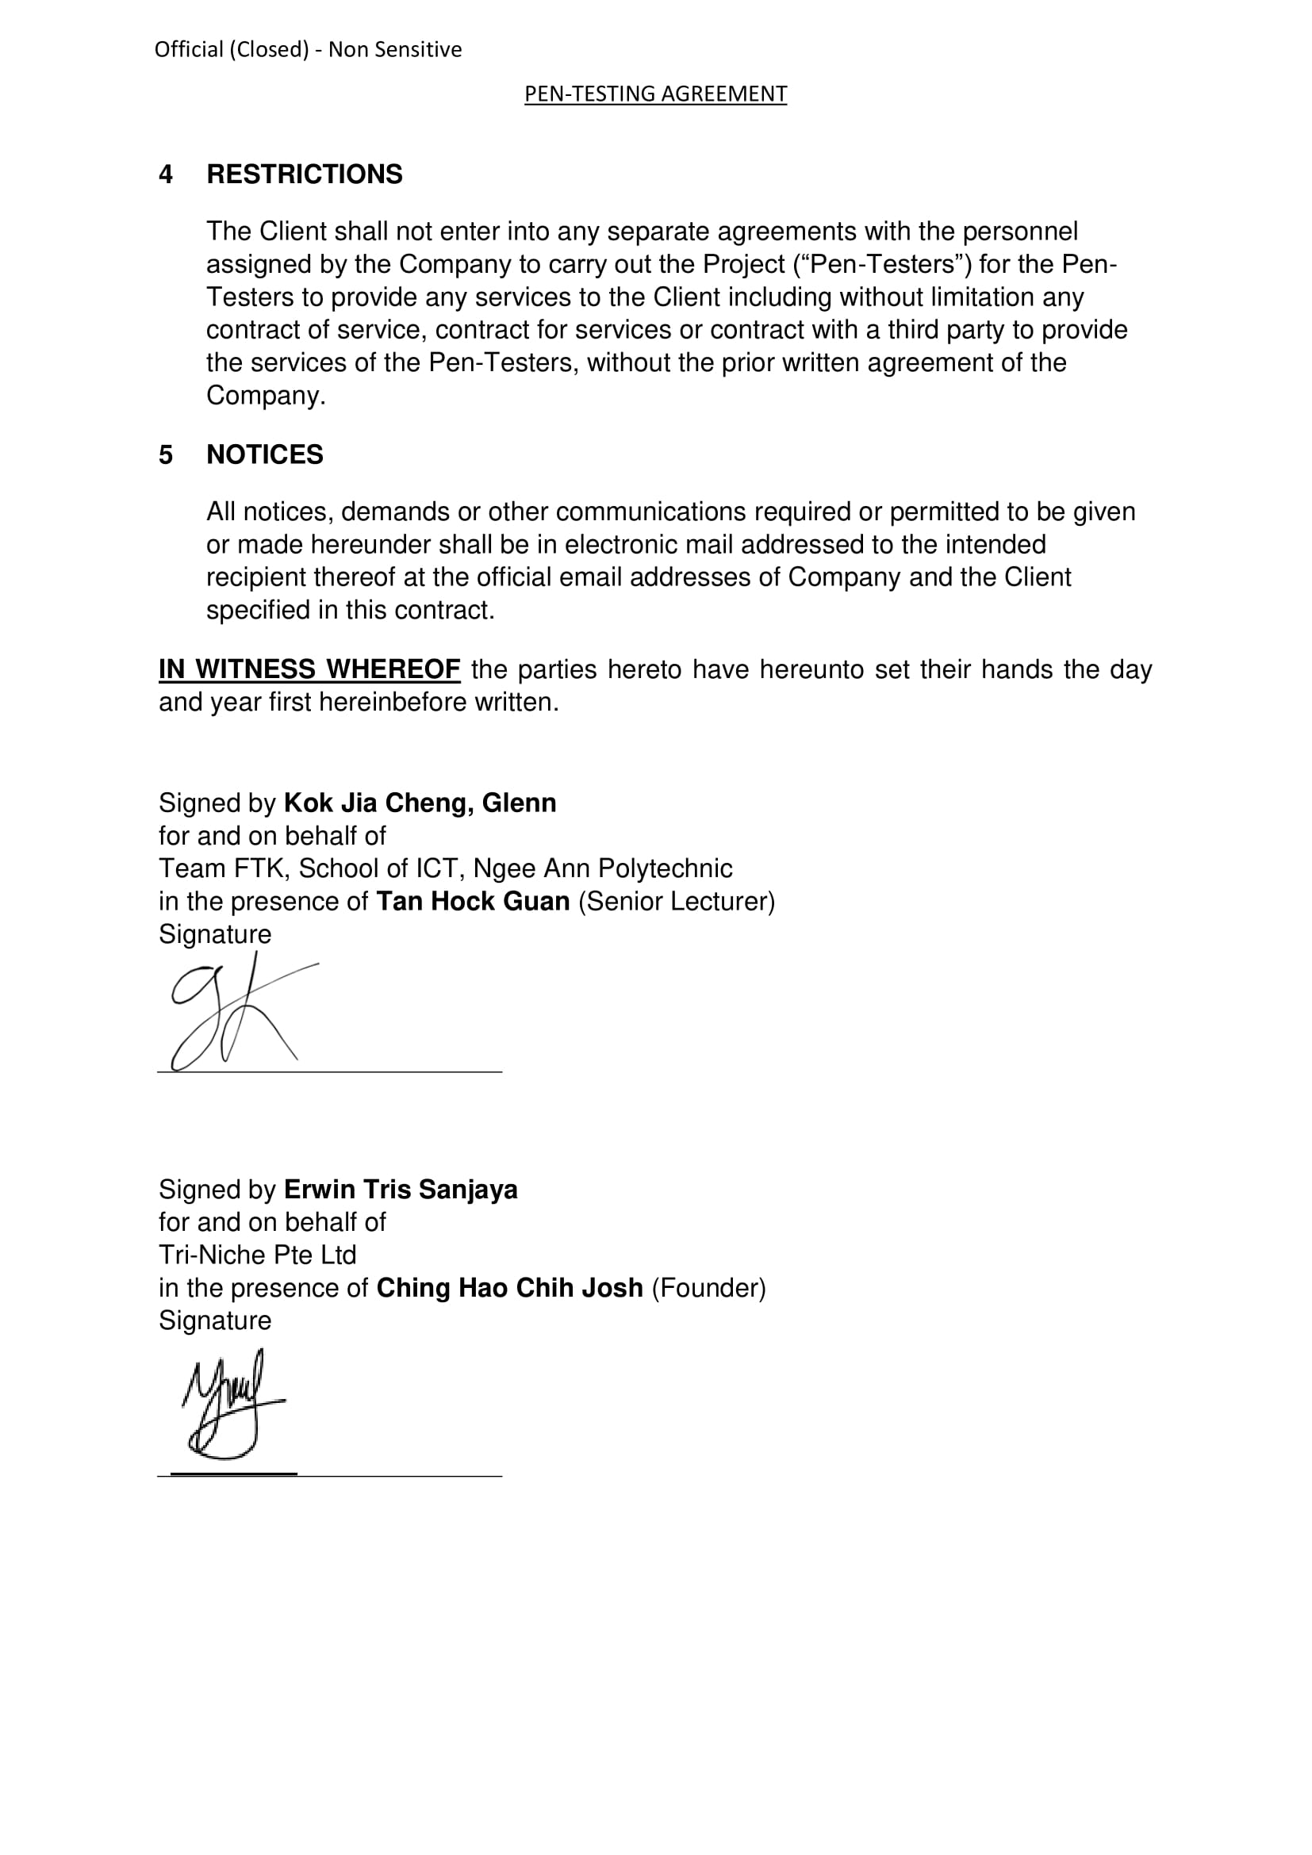

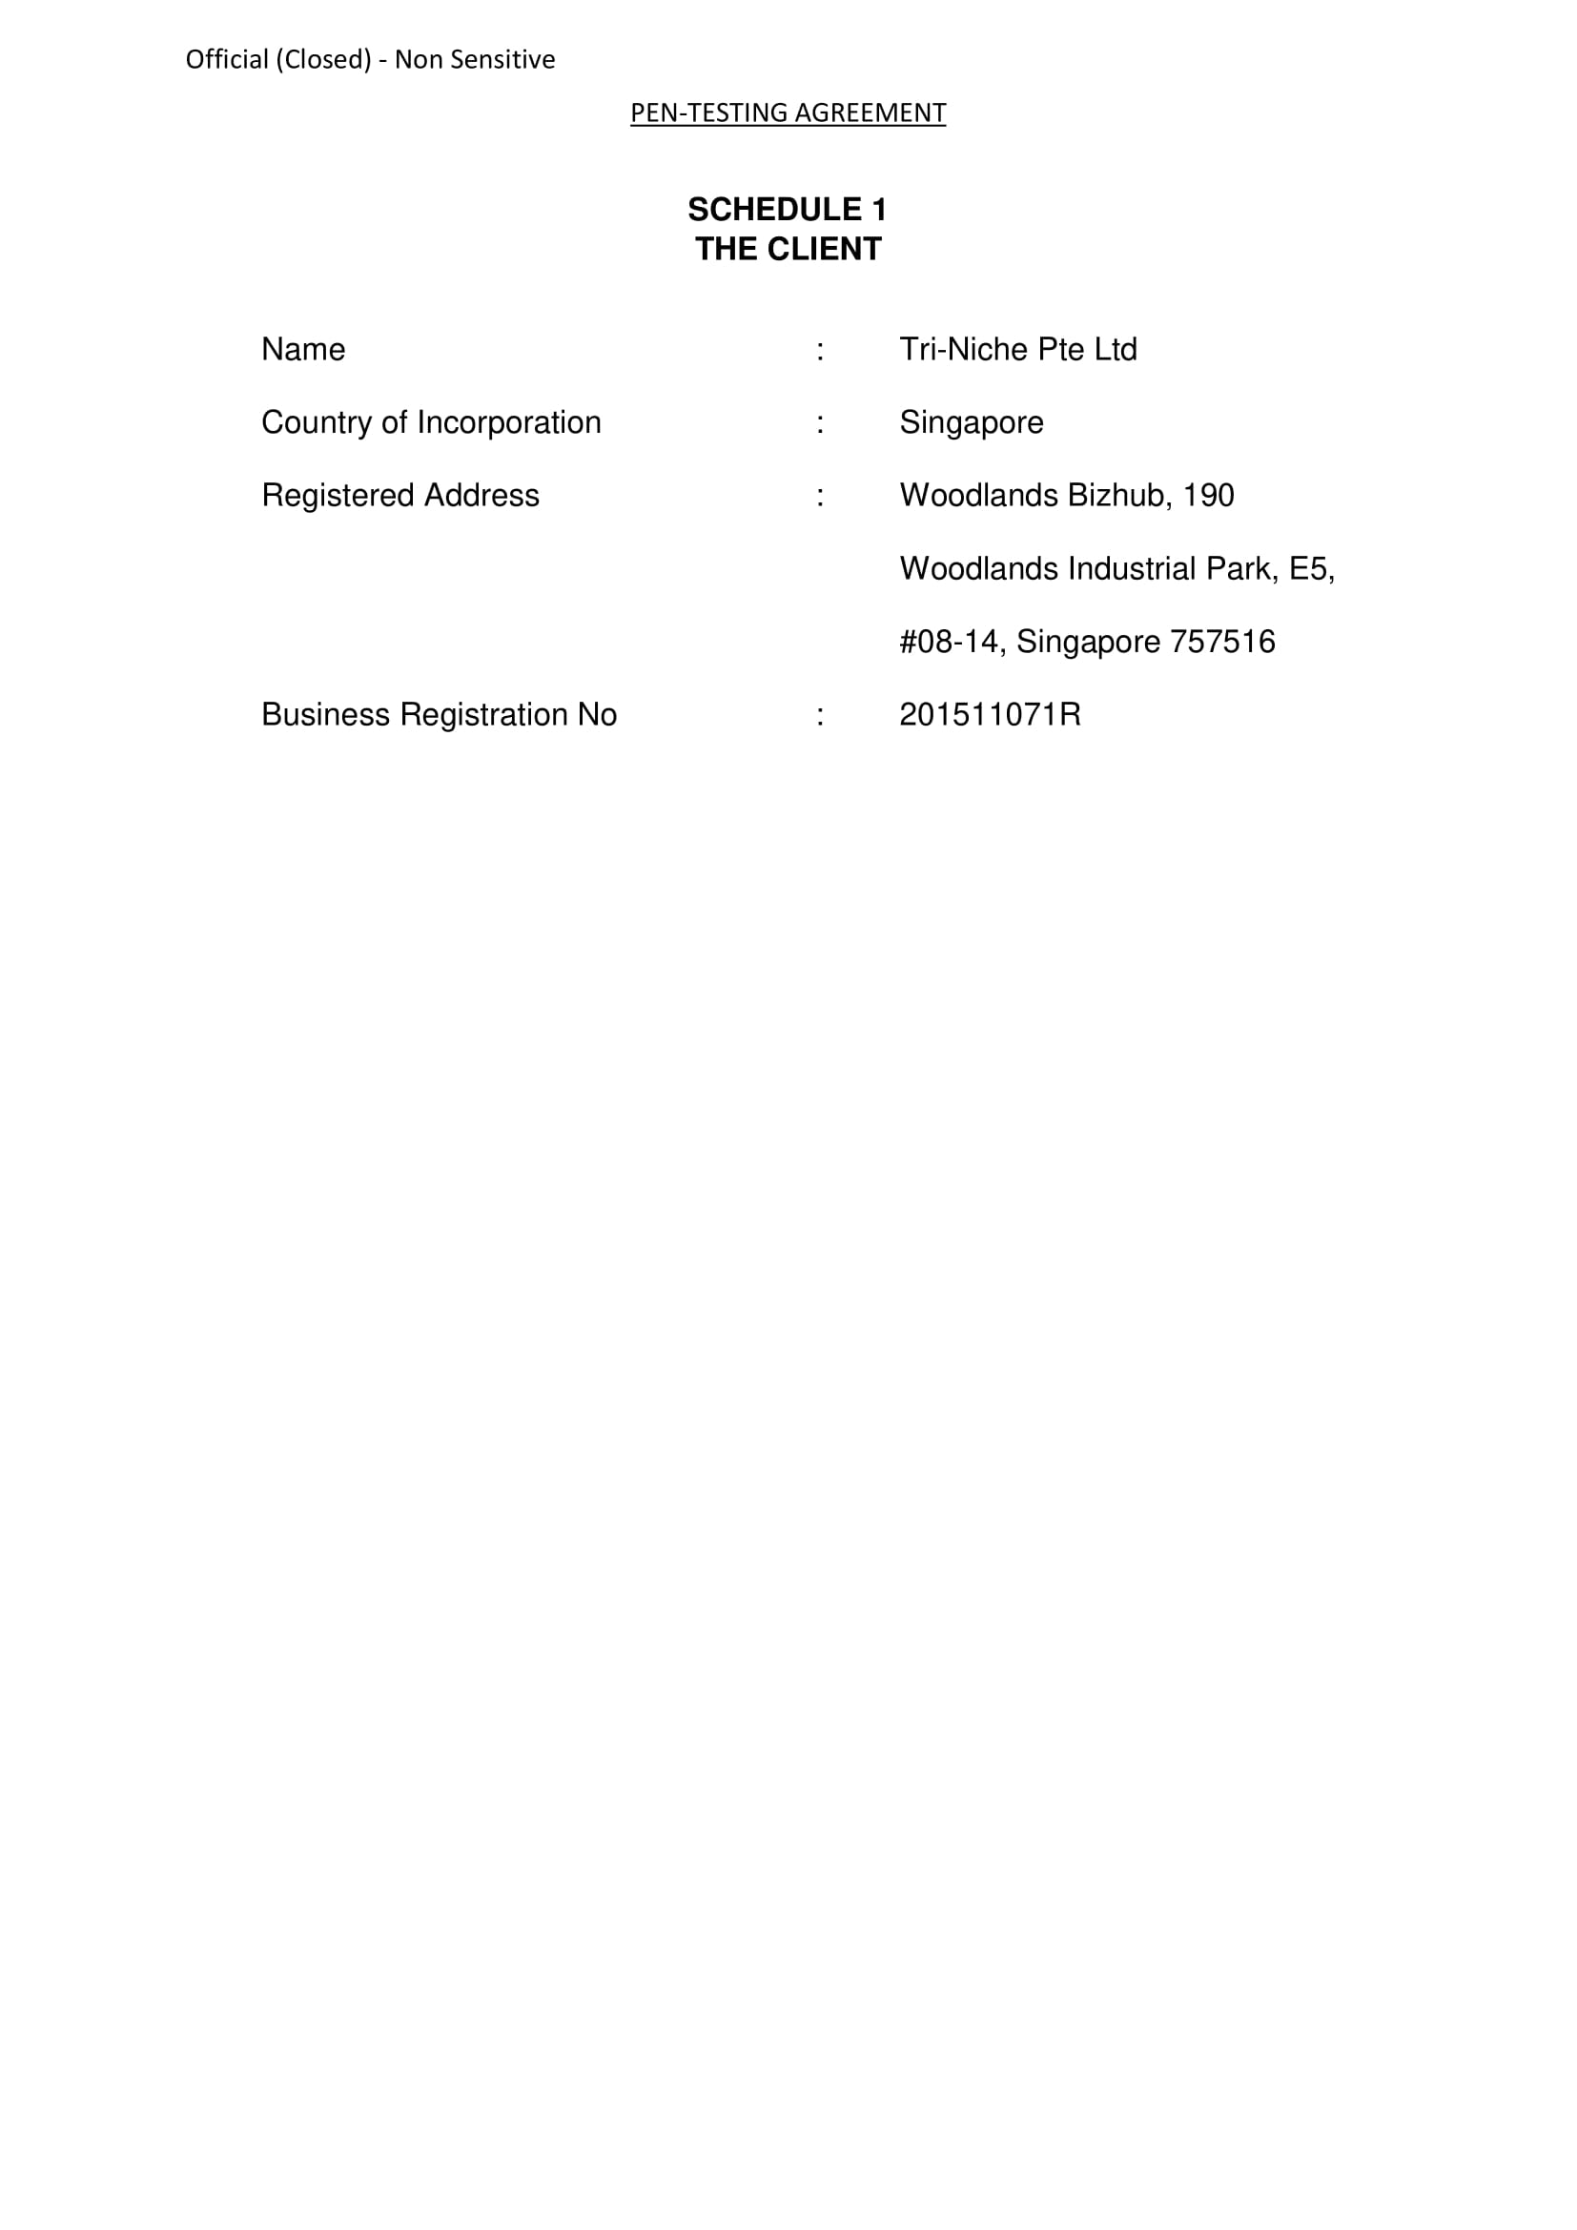

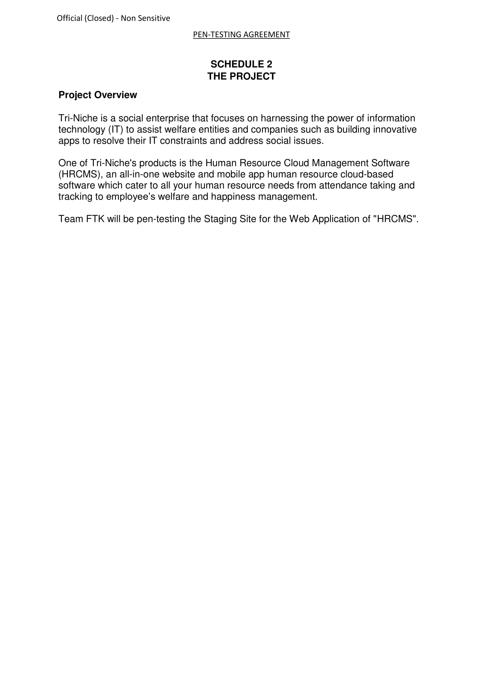

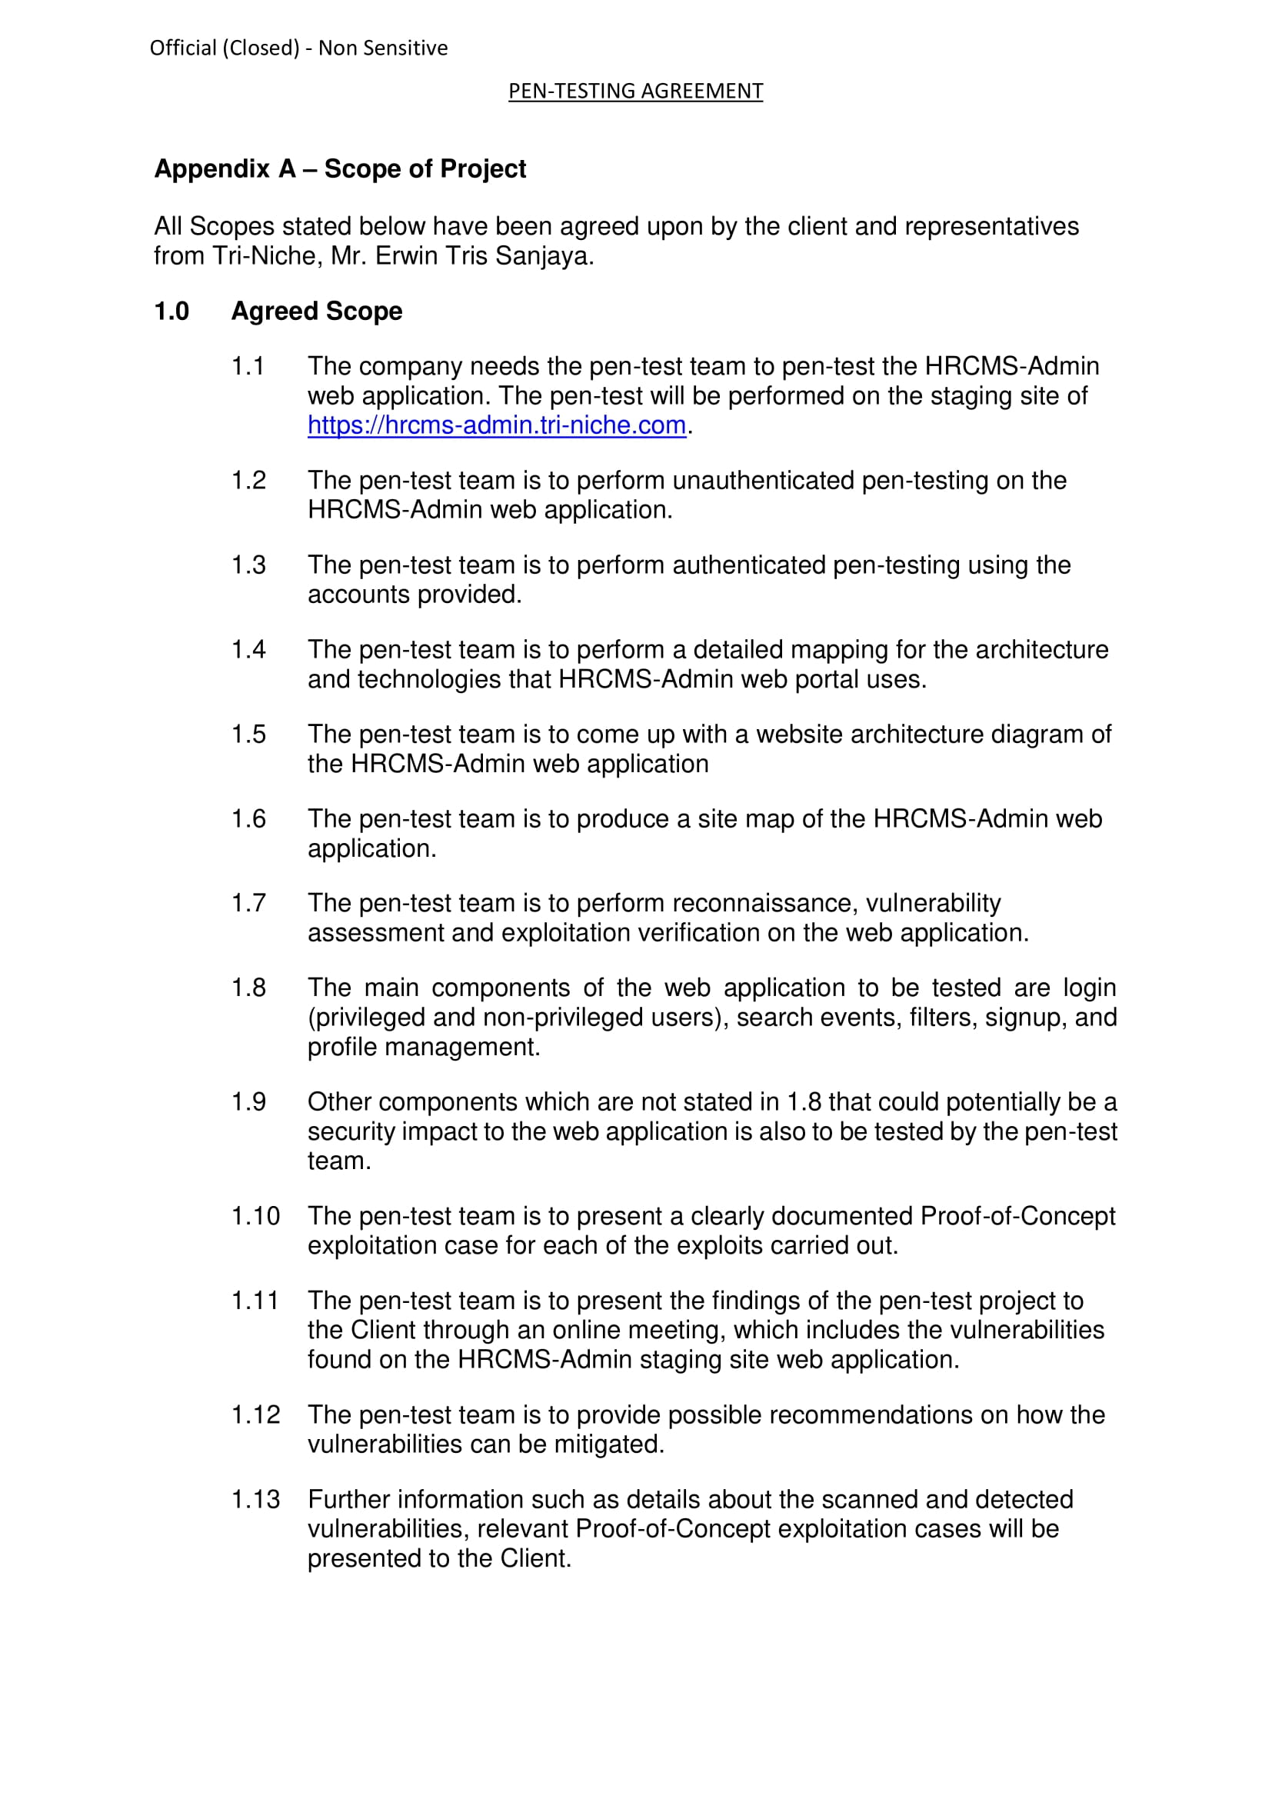

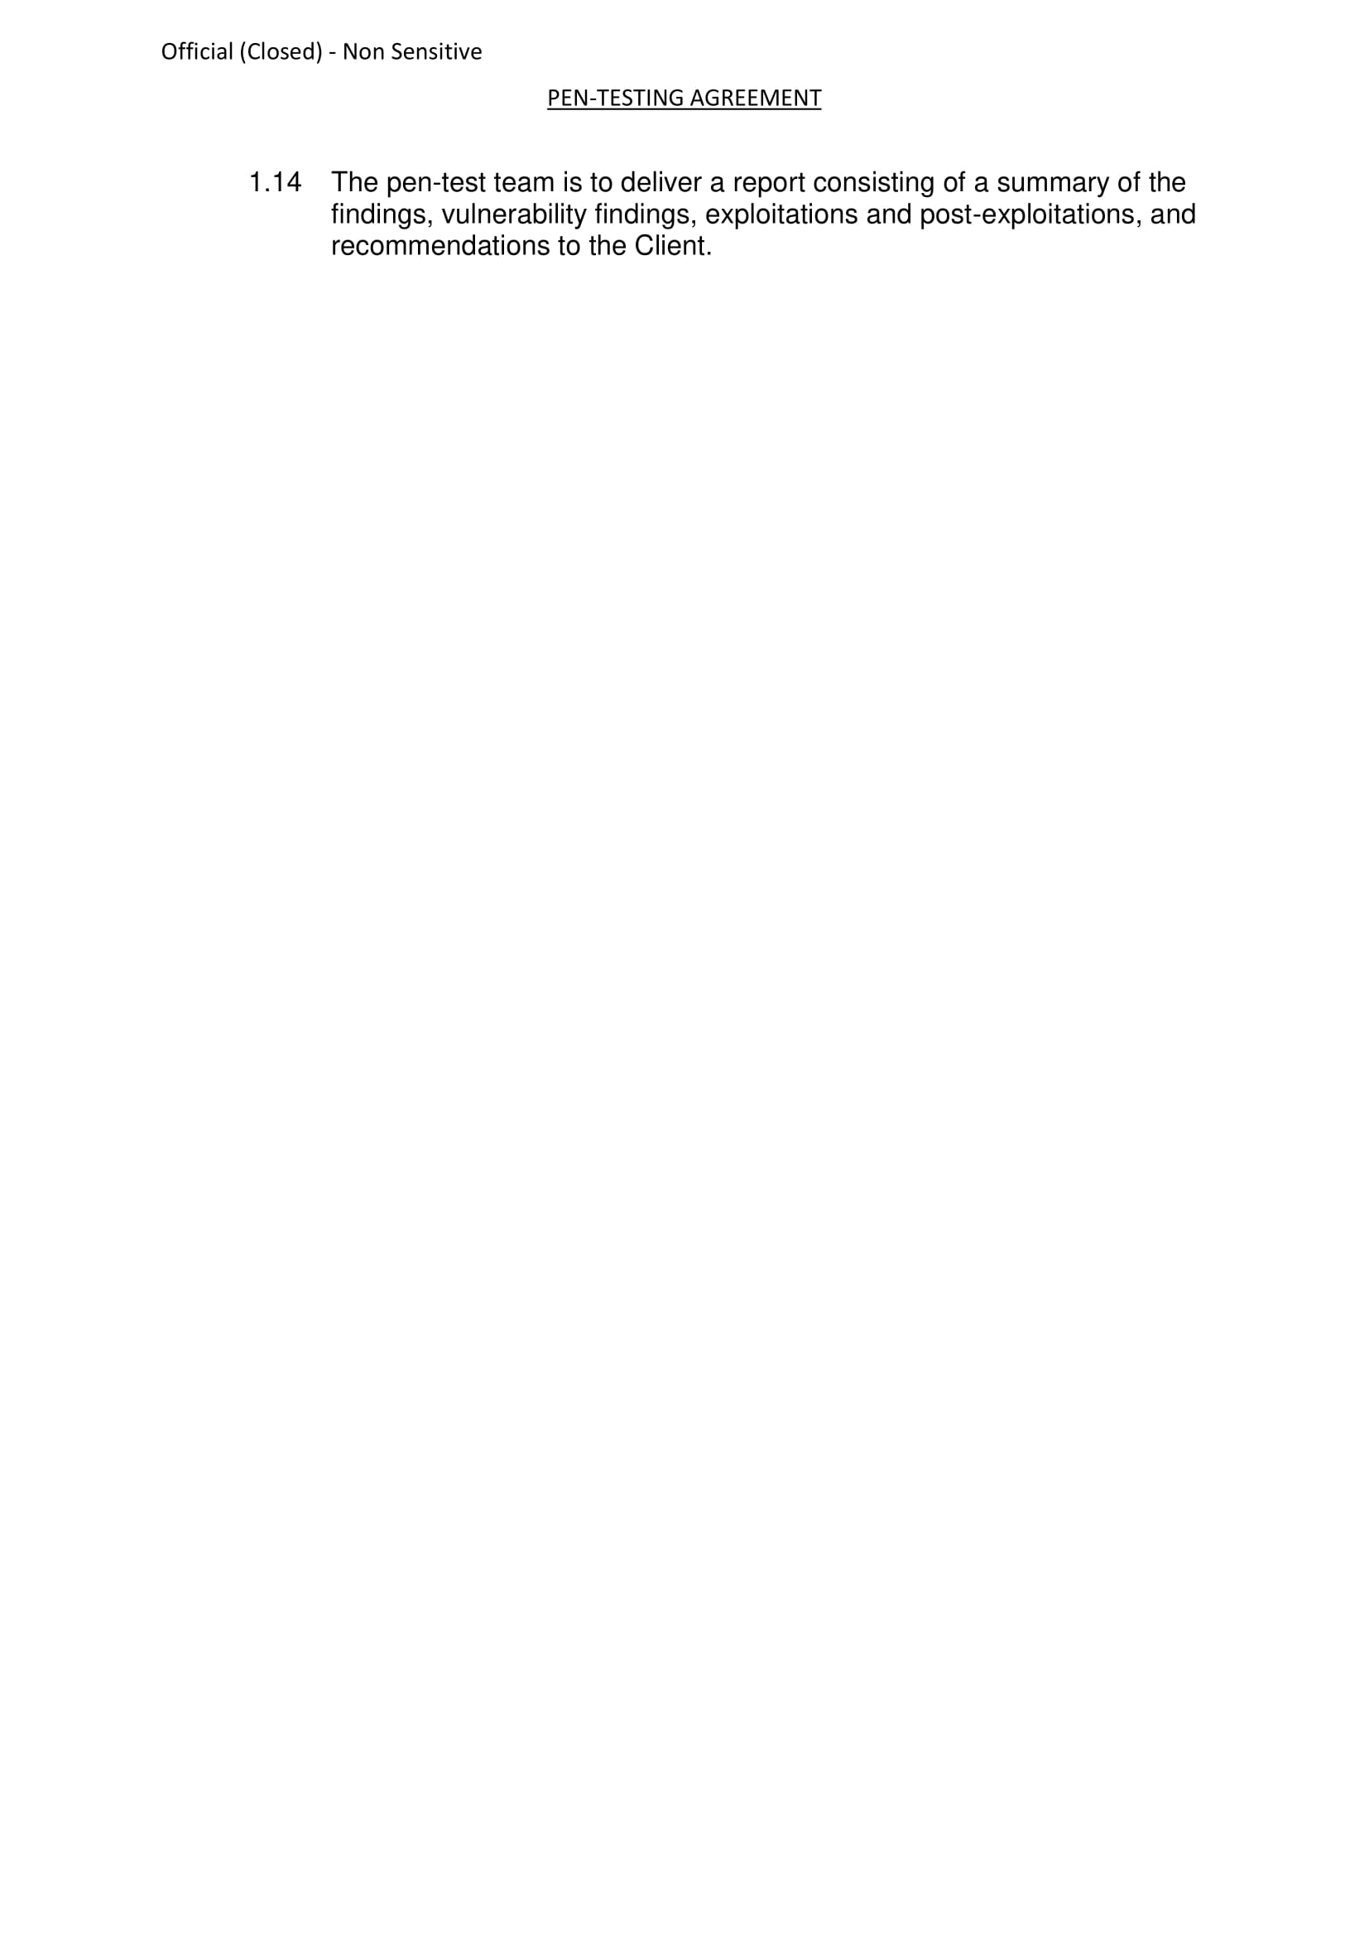

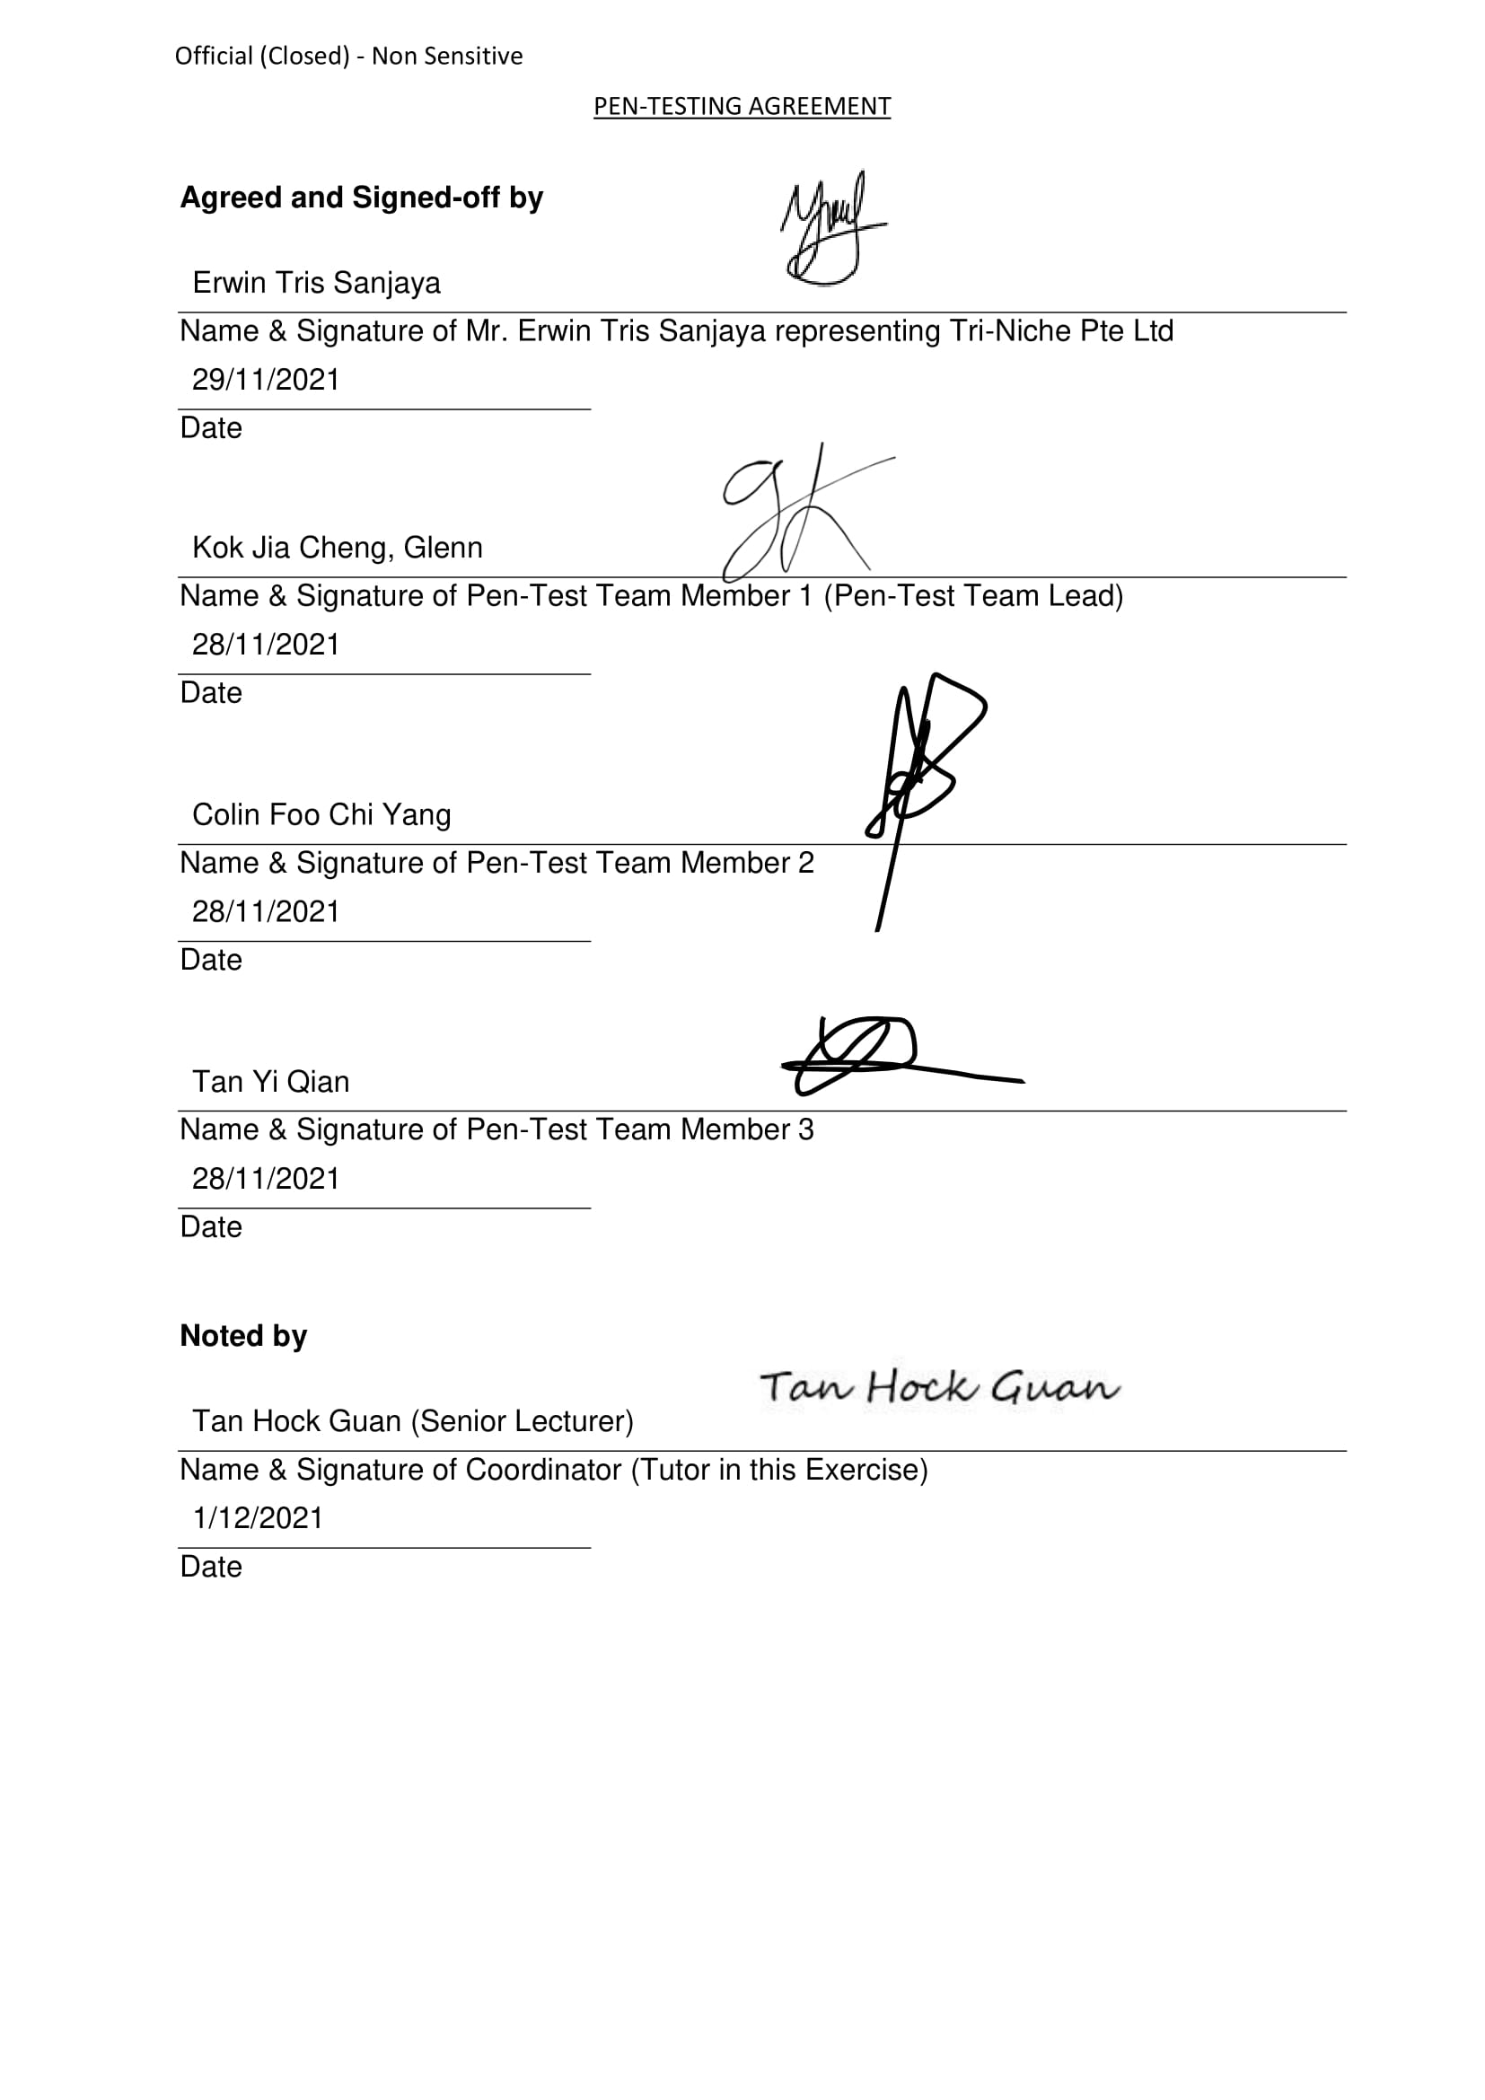

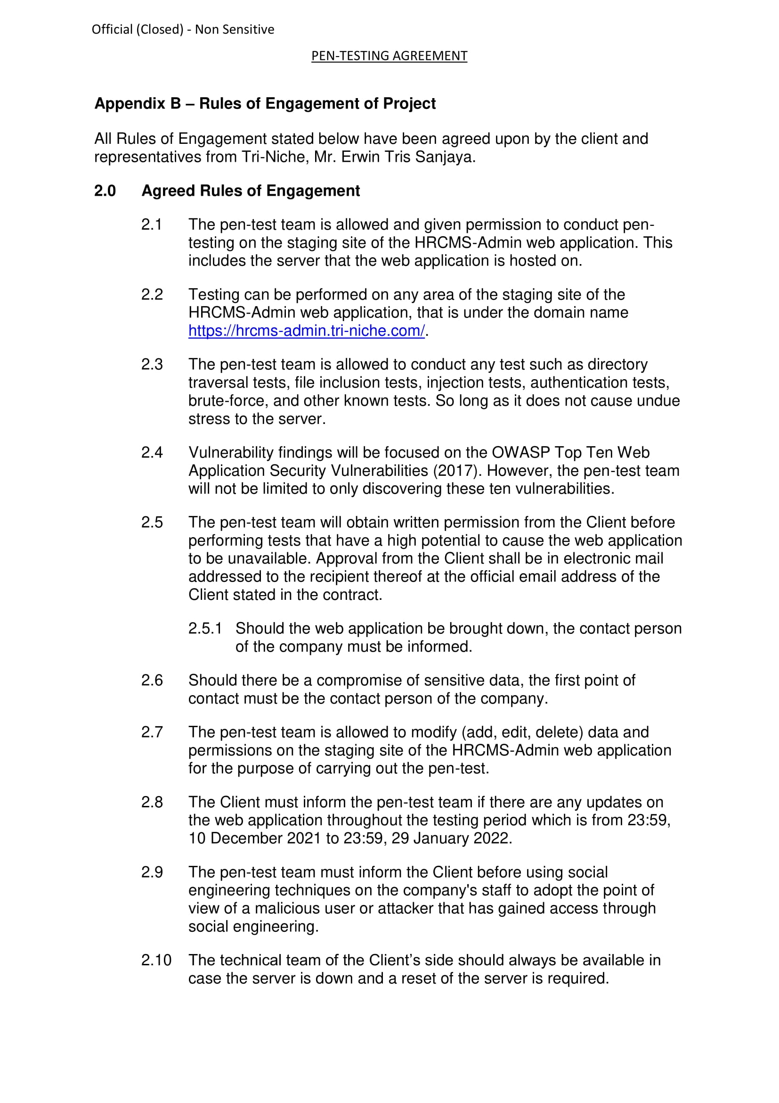

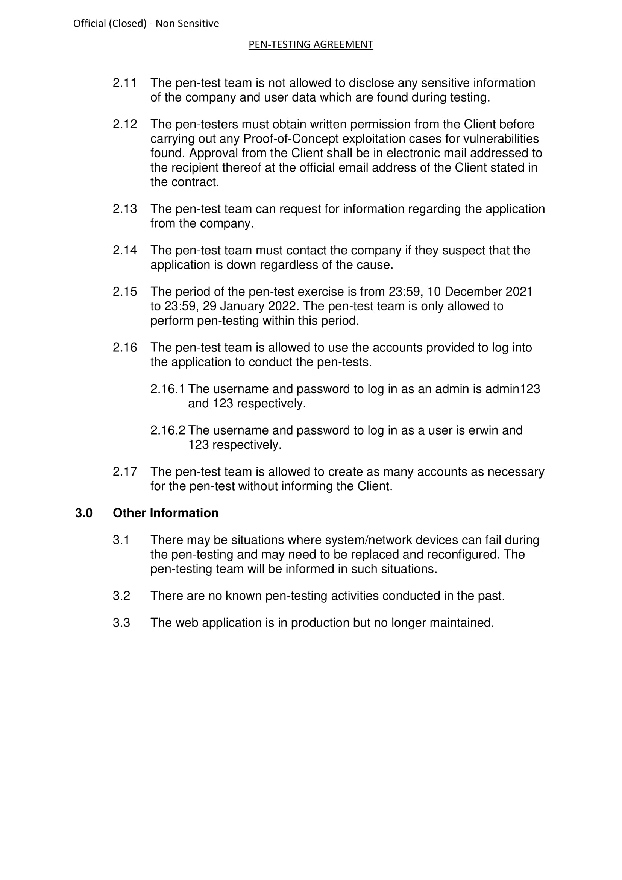

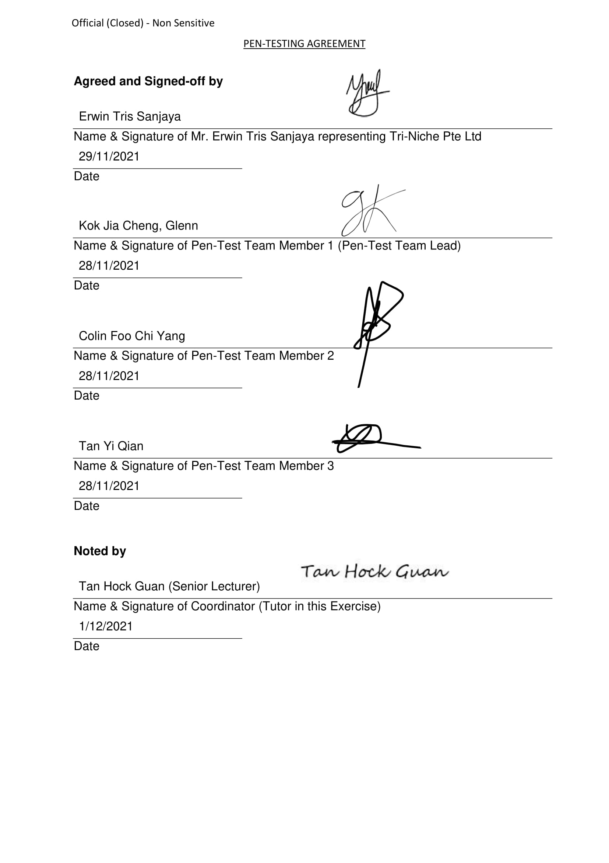

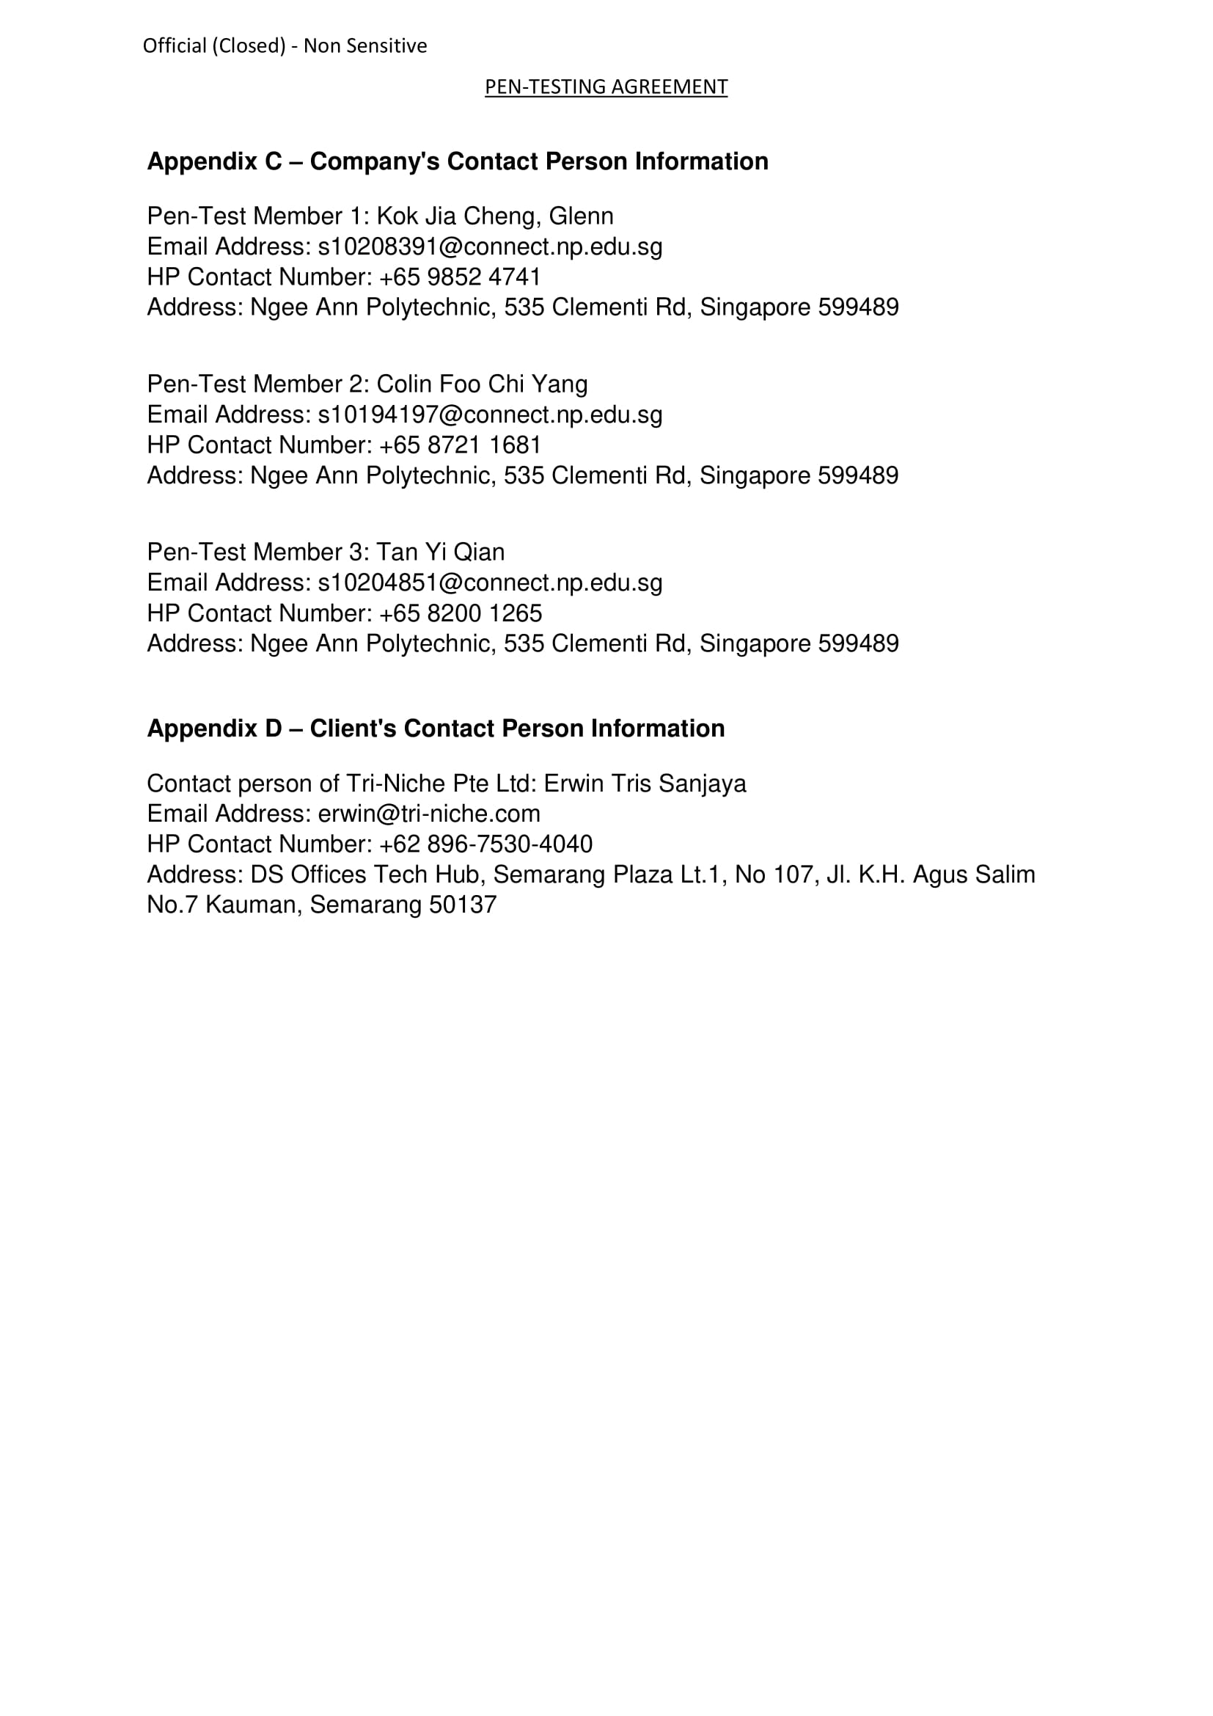

## Signed-Off Non-Disclosure Document

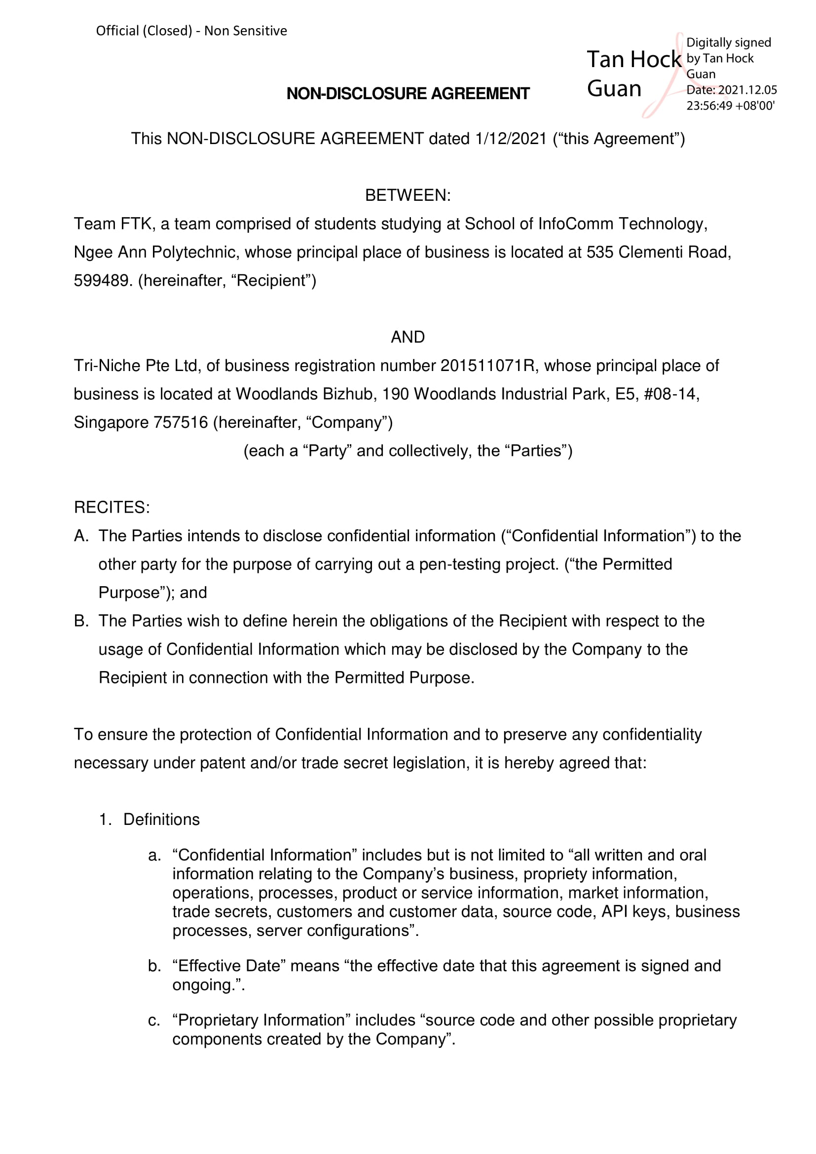

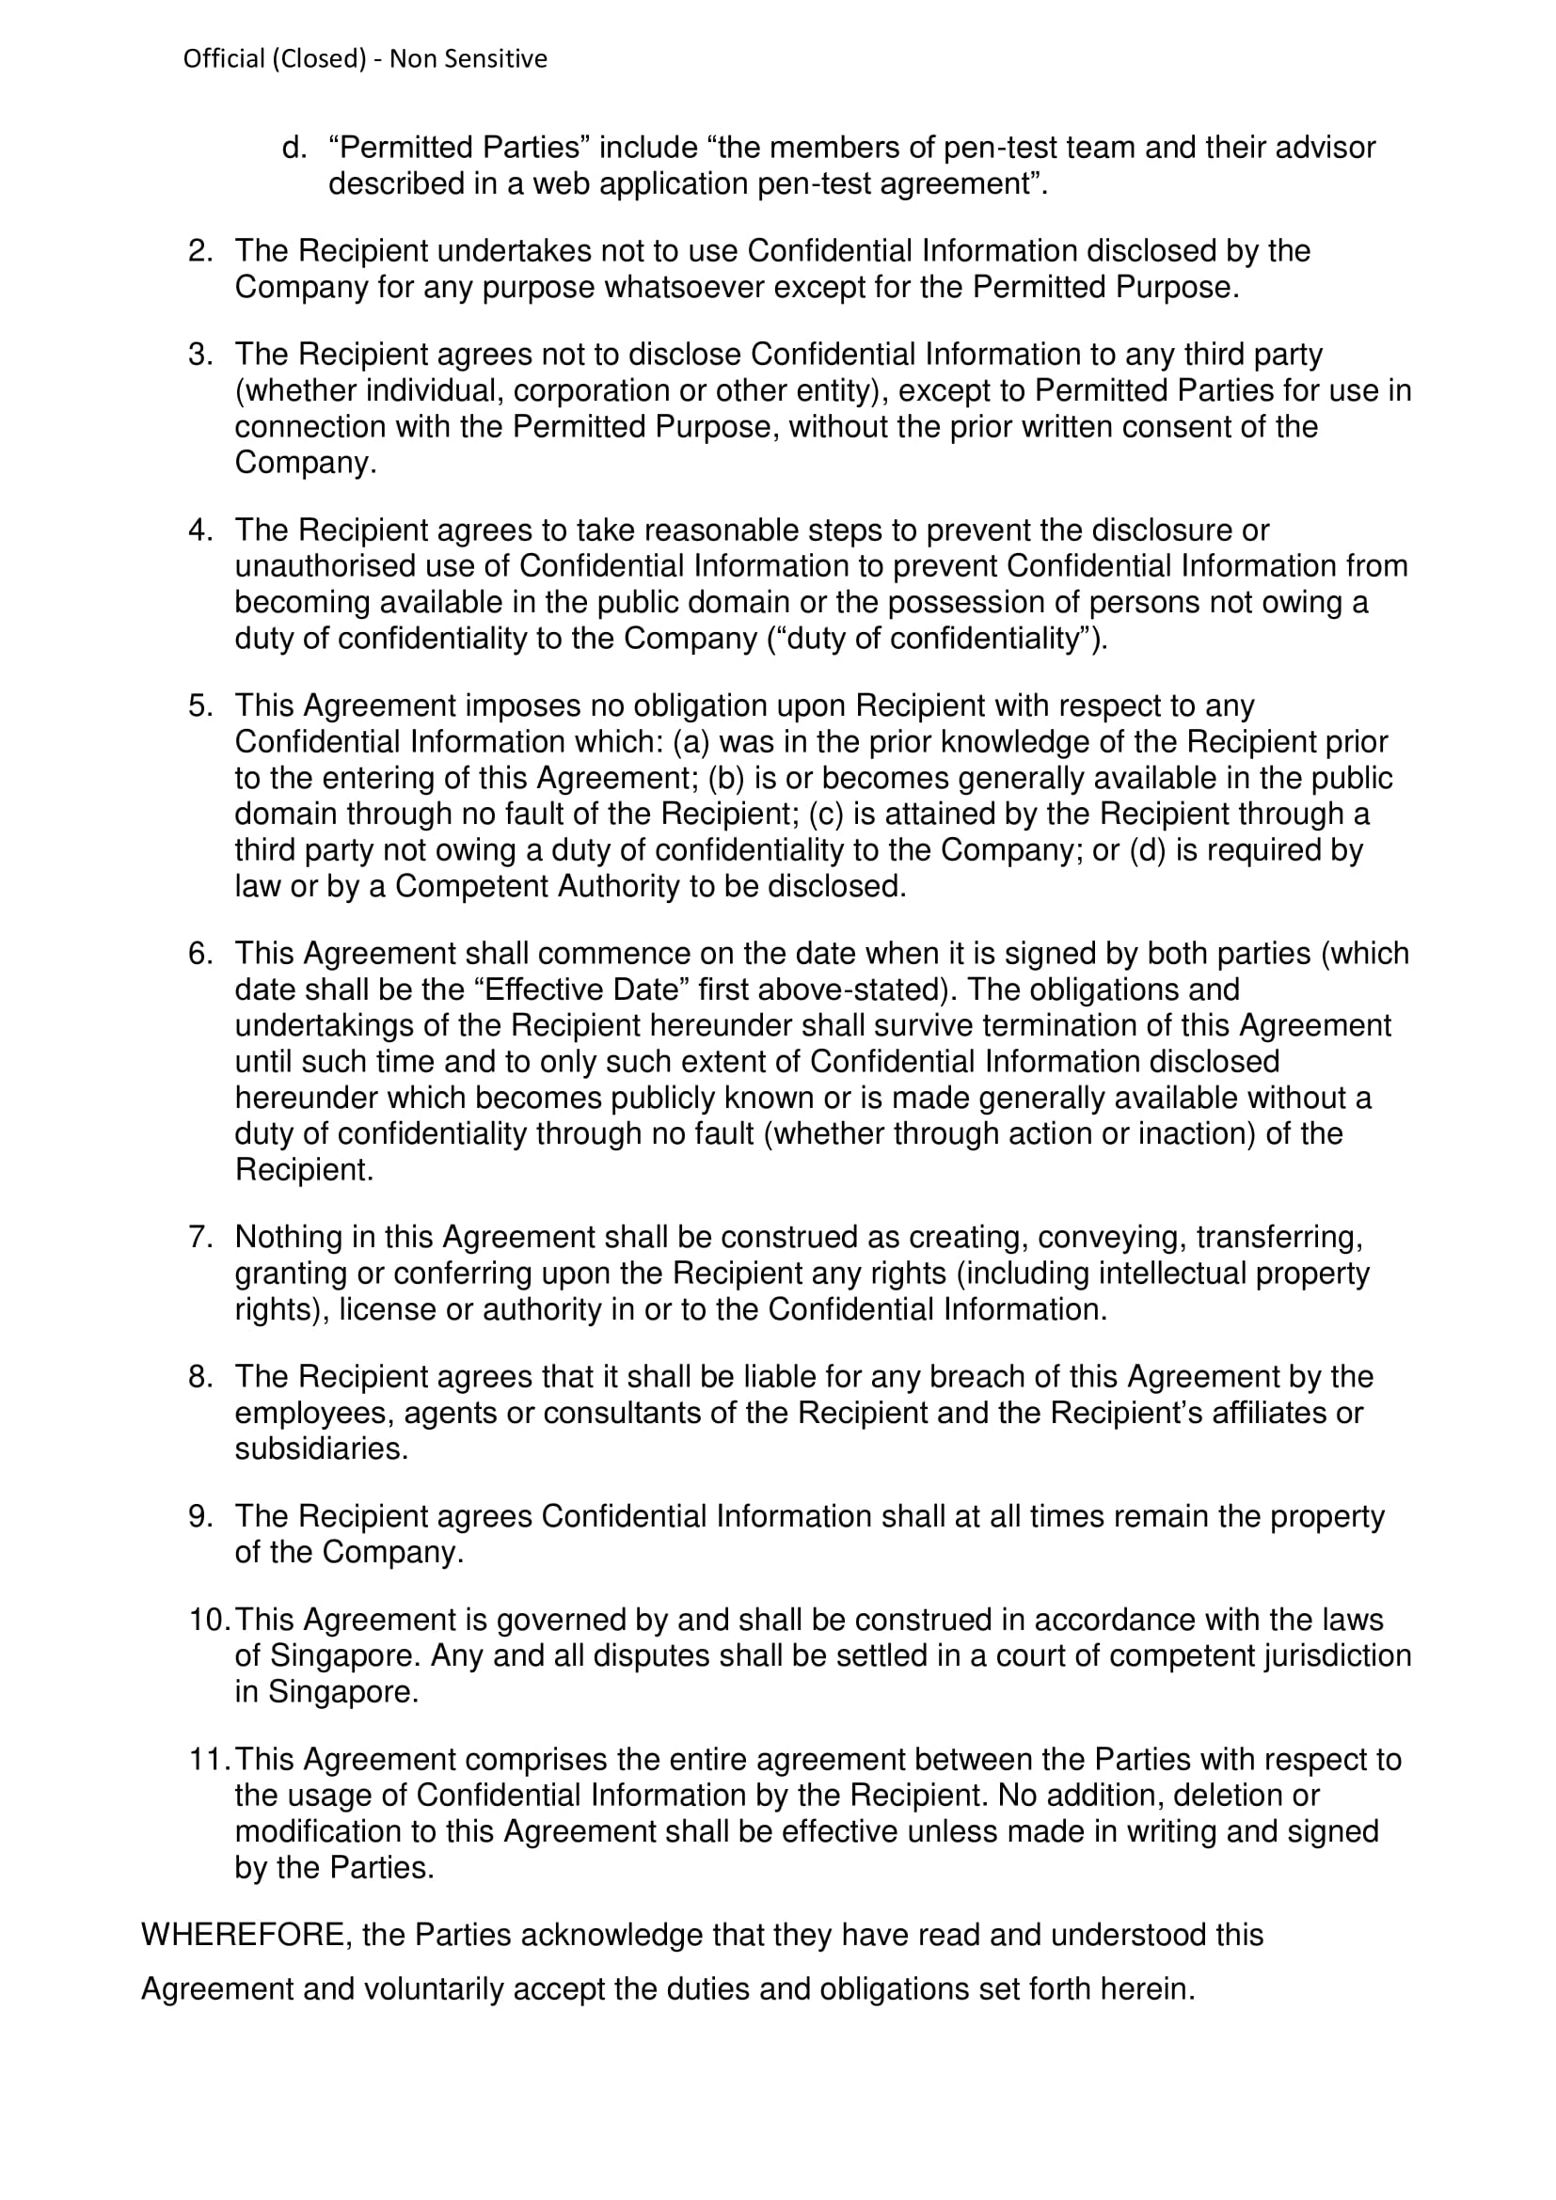

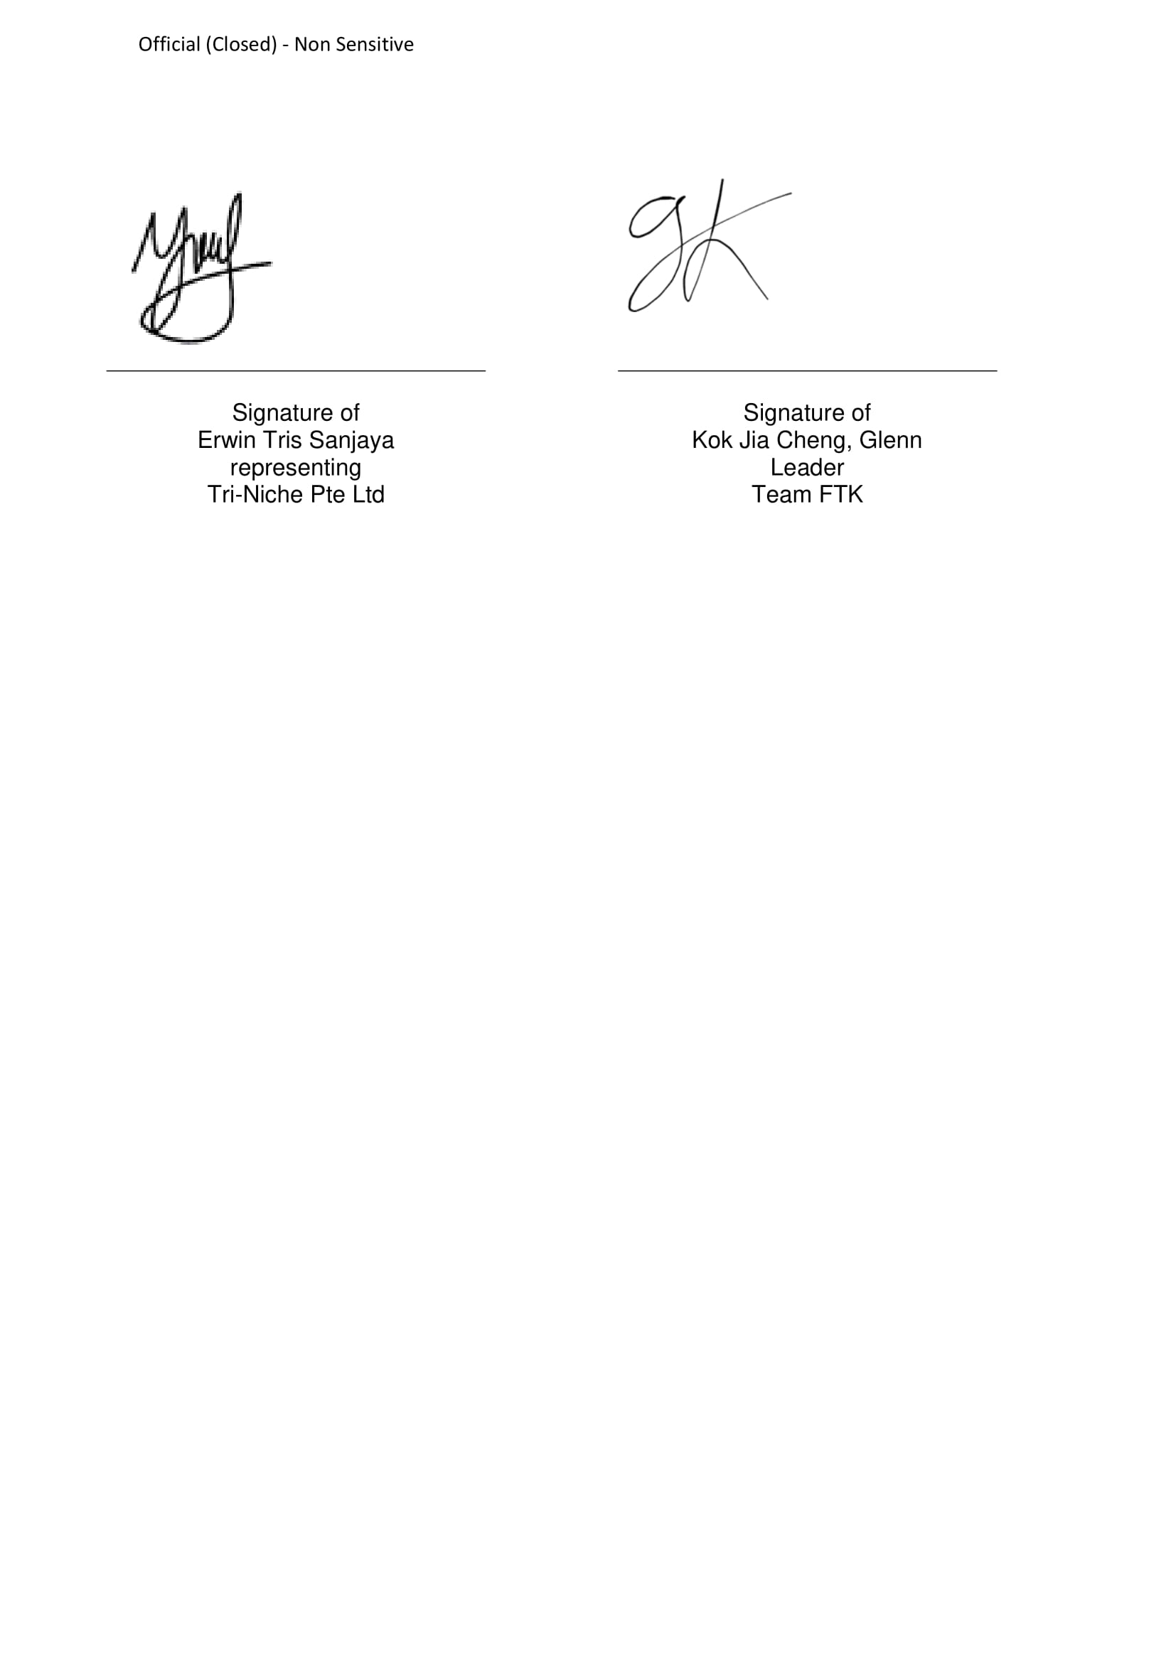

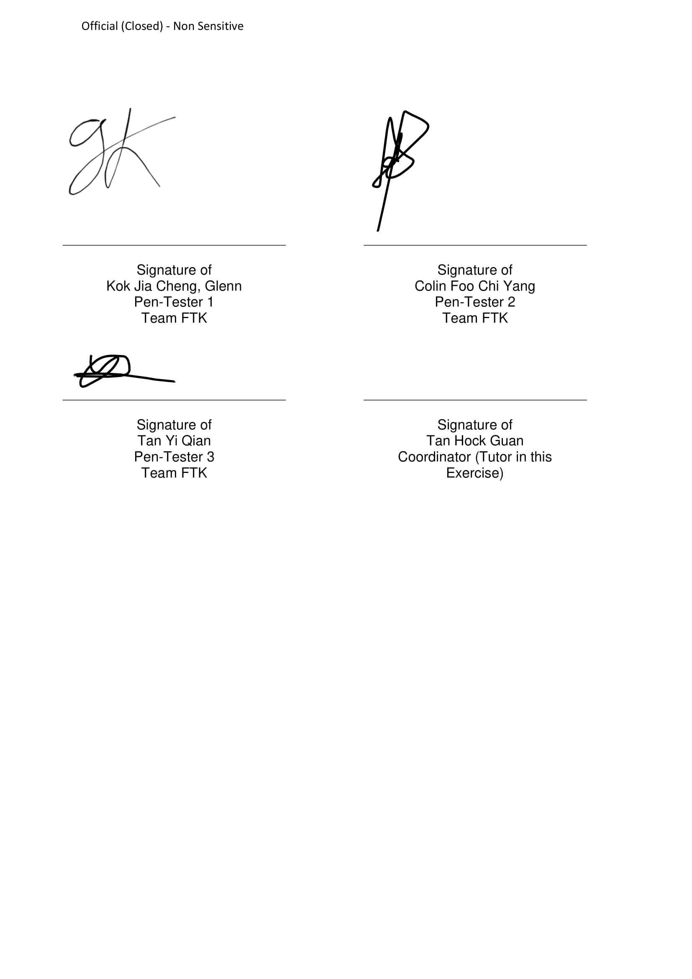

## Proof-of-Concept Use Cases

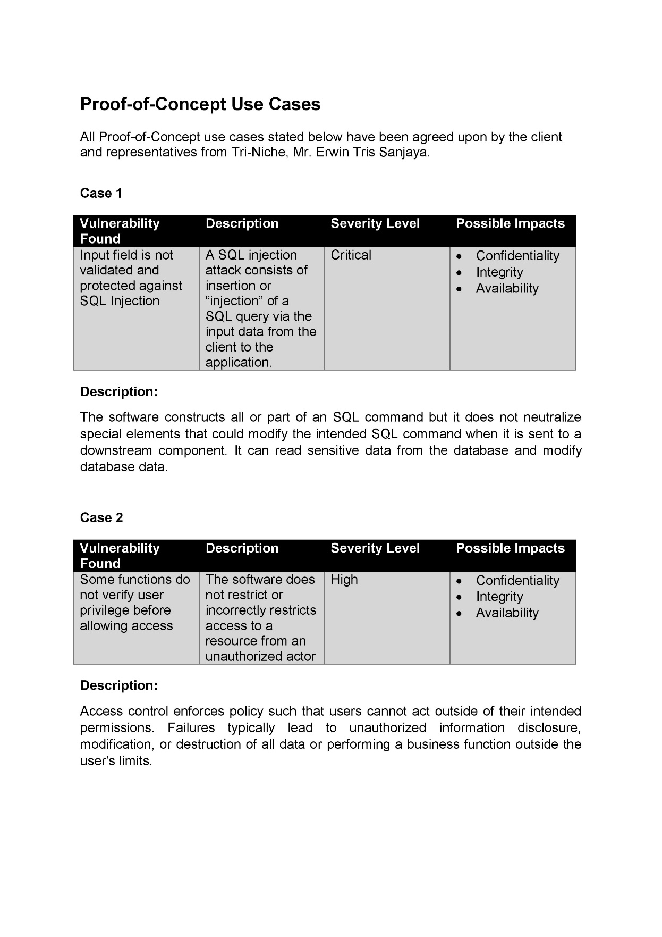

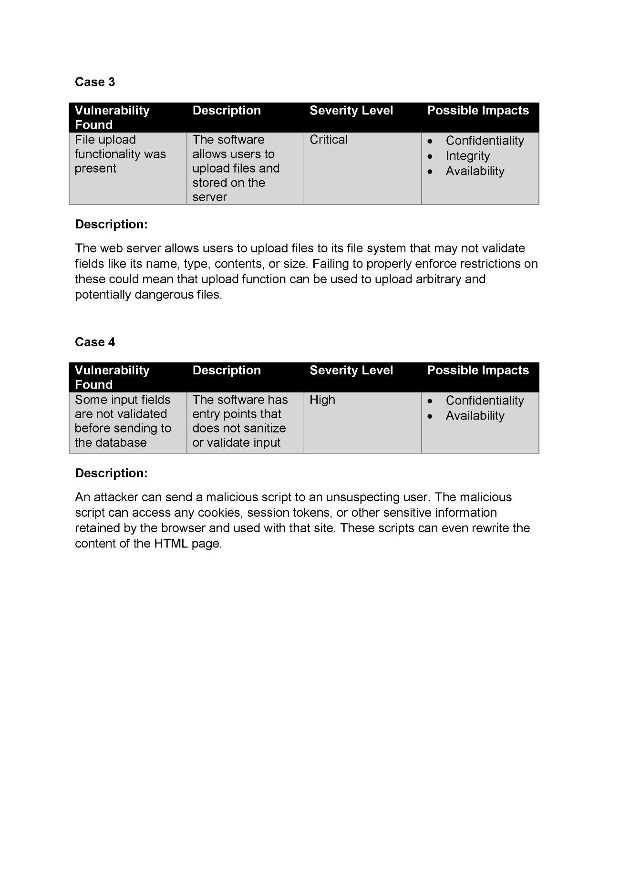

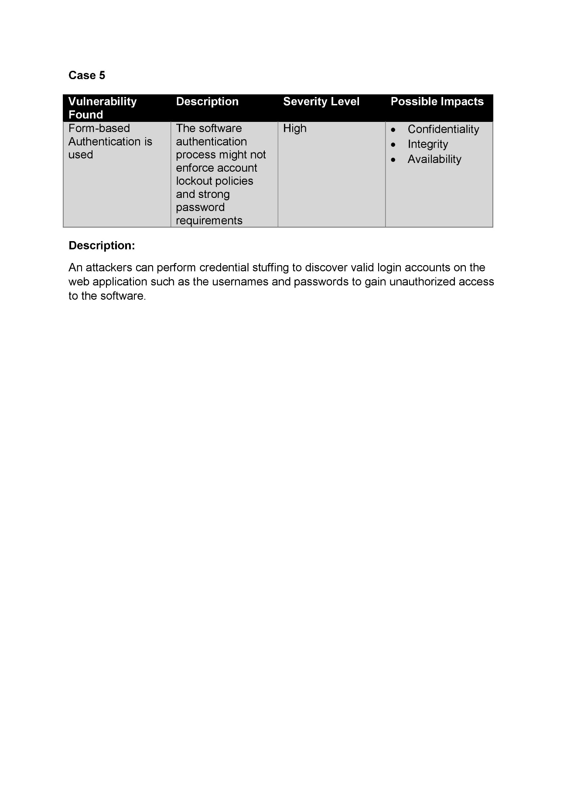

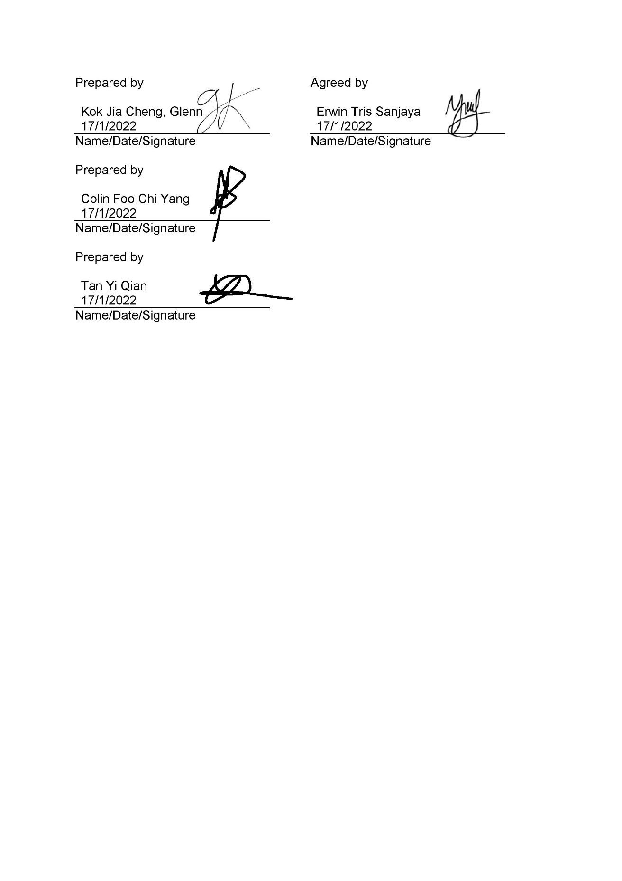

## Severity Ranking Table

**Severity - Critical:** Critical vulnerabilities need swift response using mitigation controls and direct remediation. If exploited the attacker will gain higher privileges in targeted system/application and gain deeper access into other hosts or databases. If exploited these findings will cost noteworthy losses. Furthermore, critical vulnerabilities when exploited will have a significant reputational or financial harm.

**Severity - High:** High severity vulnerabilities need to be evaluated with utmost importance. Exploiting these vulnerabilities will lead to attackers gaining administrator access to system, application, or sensitive data. It will not, however, lead to access to other hosts or databases. If left unattended, these vulnerabilities can be a substantial threat that could affect business continuity or cause financial harm.

**Severity - Medium:** Medium severity vulnerabilities should be analyzed and fixed within a short period of time. This kind of vulnerability can lead to attackers gaining non-privileged or user access into the system. If it can cause Denial-of-Service, it is also included in this category. The vulnerability may also be one which allows attackers to elevate their privilege level. Medium level vulnerabilities are threatening but not as much as high or critical vulnerabilities.

**Severity - Low:** Low severity vulnerabilities should be analyzed and fixed once the critical, high, and medium vulnerabilities have been fixed completely. These vulnerabilities may release information to unauthorized users to launch a more well-planned attack on the system. These vulnerabilities should be taken into consideration when creating a well-structured security policy and should be taken note of, however they are not immediately dangerous to businesses.

**Informational:** Informational means that it poses no threat to confidentiality, integrity, or availability of the system. Suggestions to improve on these would just be an add-on to the security measures that have already been implemented.